Power and Conflict Recap
Instructions: Roll the dice to choose a column. Roll again to decide the row. Answer. Your name will be put in the Square. Person with the most points wins!
 | 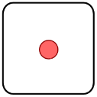 | 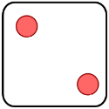 | 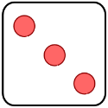 | 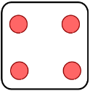 | 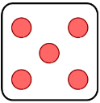 | 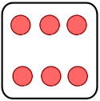
 | 1. Ozymandias – Who wrote it? What is it about? Give one key quotation. | 2. “A Hundred ______ in black and _____.” | 3. London - Who wrote it? What is it about? Give one key quotation. | 4. “Look on my works, ye _______ and _______.” | 5. Tell me 2 poems you could compare on a theme of Power of Humans | 6. “And ____ in every face I meet _____ of weakness, _____ of woe.”
 | 7. Tell me 2 poems you could compare on a theme of Power of Nature | 8. The Prelude - Who wrote it? What is it about? Give one key quotation. | 9. Give an example of a dramatic monologue. | 10. My Last Duchess - Who wrote it? What is it about? Give one key quotation. | 11. “A ____ peak, black and ____,… Up reared its ____.” | 12.”I gave ________; then all _____ stopped together.”
 | 13. Tell me 2 poems you could compare on a theme of Negative Emotions – Anger. | 14. “Theirs is not to reason ___, theirs is but to do and ___.” | 15. The Charge of the Light Brigade - Who wrote it? What is it about? Give one key quotation. | 16. Tell me 2 poems you could compare on a theme of effects of conflict. | 17. Exposure - Who wrote it? What is it about? Give one key quotation. | 18. “Pale flakes with fingering _____ come feeling for our _____.”
 | 19. “We sit tight while wind dives and ______ invisibly.” | 20. Tissue - Who wrote it? What is it about? Give one key quotation. | 21. “King, honour, human _______, etcetera. Dropped like _______” | 22. Storm on the Island - Who wrote it? What is it about? Give one key quotation. | 23. “His bloody ____ in my _______ hands.” | 24. Bayonet Charge - Who wrote it? What is it about? Give one key quotation.
 | 25. Remains - Who wrote it? What is it about? Give one key quotation. | 26. “I am _______ by an impression of ________.” | 27. Poppies - Who wrote it? What is it about? Give one key quotation. | 28. “He must have wondered which was the _____ way to ___.” | 29. War Photographer - Who wrote it? What is it about? Give one key quotation. | 30. Tell me 2 poems you could compare on a theme of Reality of conflict.
 | 31. Tell me 2 poems you could compare on a theme of Identity. | 32. The Emigree - Who wrote it? What is it about? Give one key quotation. | 33. “Bandage up me ____ with me own ______, Blind me to my own _______.” | 34. Kamikaze - Who wrote it? What is it about? Give one key quotation. | 35. “I listened hoping to hear your ________ voice catching on the wind”. | 36. Checking Out Me History - Who wrote it? What is it about? Give one key quotation. .

