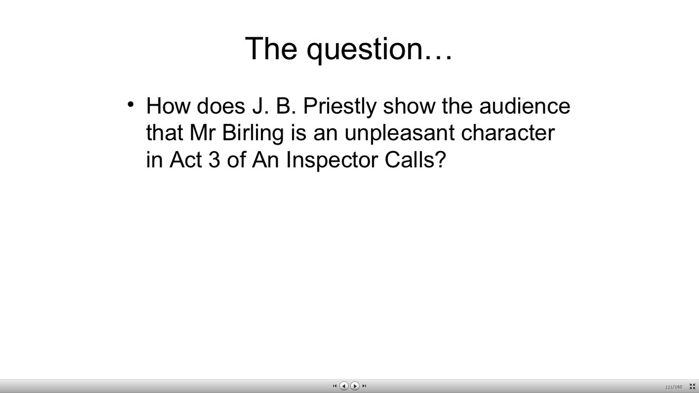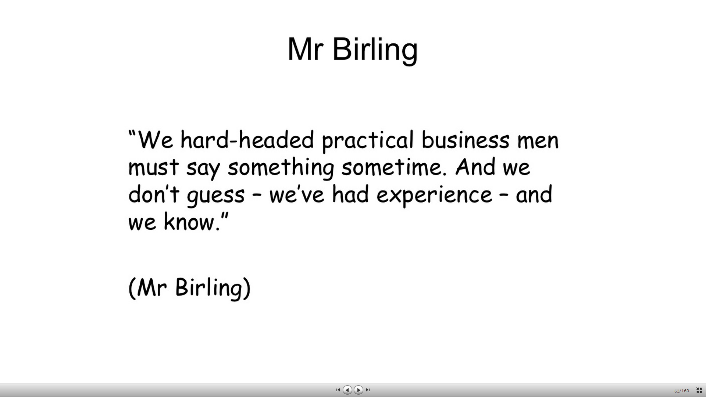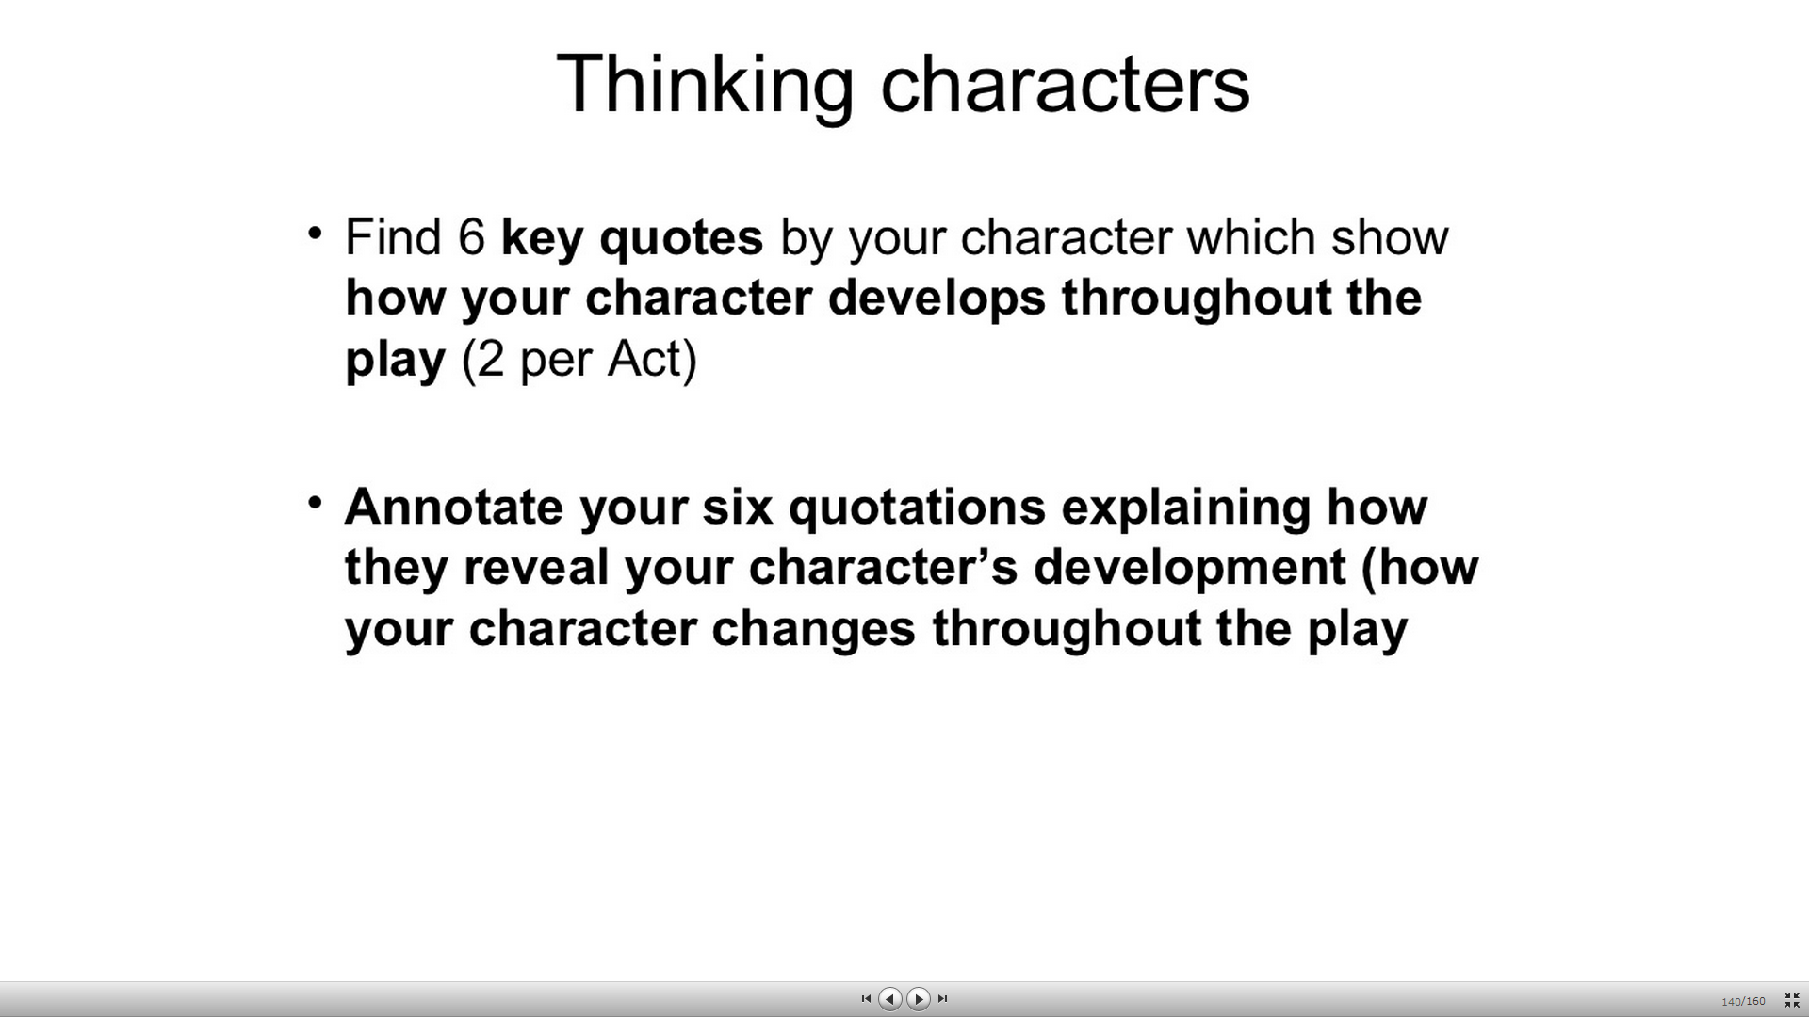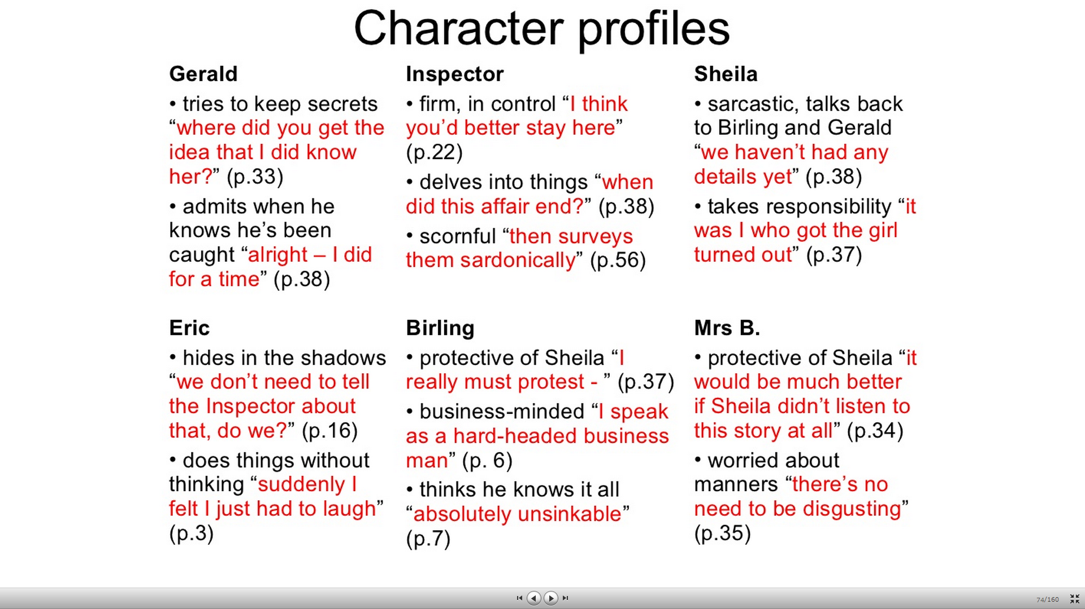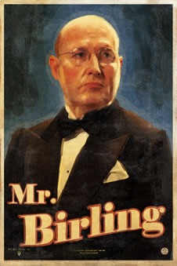

* **Bitesize:**
* He is described at the start as a "heavy-looking, rather portentous man in his middle fifties but rather provincial in his speech."
* He has worked his way up in the world and is **proud**of his achievements. He boasts about having been Mayor and tries (and fails) to impress the Inspector with his local standing and his influential friends.
* However, he is aware of people who are his social superiors, which is why he shows off about the port to Gerald, "it's exactly the same port your father gets."He is proud that he is likely to be knighted, as that would move him even higher in social circles.
* He claims the party "is one of the happiest nights of my life." This is not only because Sheila will be happy, but because a merger with Crofts Limited will be good for his business.
* He is **optimistic** for the future and confident that there will not be a war. As the audience knows there *will* be a war, we begin to doubt Mr Birling's judgement. (If he is wrong about the war, what else will he be wrong about?)
* He is extremely **selfish**:
* He wants to protect himself and his family. He believes that socialist ideas that stress the importance of the community are "nonsense" and that "a man has to make his own way."
* He wants to protect Birling and Co. He cannot see that he did anything wrong when he fired Eva Smith - he was just looking after his business interests.
* He wants to protect his reputation. As the Inspector's investigations continue, his selfishness gets the better of him: he is worried about how the press will view the story in Act II, and accuses Sheila of disloyalty at the start of Act III. He wants to hide the fact that Eric stole money: "I've got to cover this up as soon as I can."
* At the end of the play, he knows he has lost the chance of his knighthood, his reputation in Brumley and the chance of Birling and Co. merging with their rivals. Yet he hasn't learnt the lesson of the play: he is unable to admit his responsibility for his part in Eva's death.