Mock Exam Preparation – Unit 1: Understanding and Producing Non Fiction Texts
Section A Question 3:
Sample response:
The question, ‘were we in the gully?’ is very effective and very tense. By this point in the story, we have realised that they are on a mountain-side and are trying to get to a camp. This is a dangerous situation and the fact they do not know where they are suggests they are in trouble. The question here makes the reader doubt the safety of the characters. ‘Panic’ implies that Pete has seen something which means he is in the wrong place; he might not make it. This is all very tense and exciting to read and makes you want to know what will happen to them.
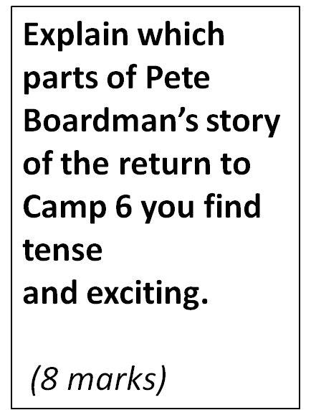

- In the paragraph above, identify where the answer shows interpretation and understanding of the quotations.
- How could the response above be improved?
- Try writing your own response to this question, using the mark scheme to help. [PEW]

