Mock Exam Preparation – Unit 1: Understanding and Producing Non Fiction Texts
Section A Question 2:
Sample response:
The headline ‘Fearsome Tyrannosaurus rex Sue may have died of a sore throat’ uses the word ‘fearsome’ to reinforce the reader’s view: we might view such a large predator as fearless and immune to disease but this is contrasted with the end of the sentence where she is described as being killed by a ‘sore throat’. We would not expect this to kill such an animal. This links with the article where it described her injuries: ‘ a damaged shoulder’ and ‘three broken ribs’. Yet she survived these and was, surprisingly, killed by something seemingly as common and harmless as a sore throat.

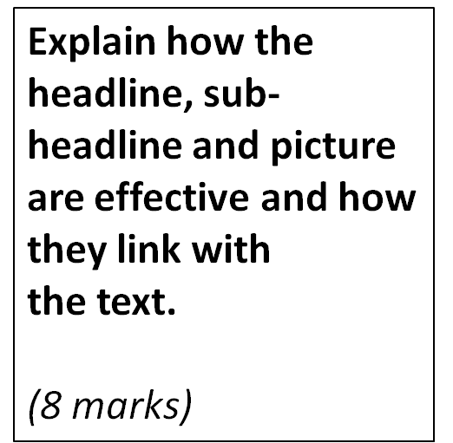

1. Identify the following structure in the above response: [ILE]
- An interpretation of the message and effect of the headline;
- Links between the headline and the text;
- Appropriate quotation to support comment.

2. How could the response above be improved?
3. Try writing your own response to this question, using the mark scheme to help.

