Mock Exam Preparation – Unit 1: Understanding and Producing Non Fiction Texts
Section A Question 1:
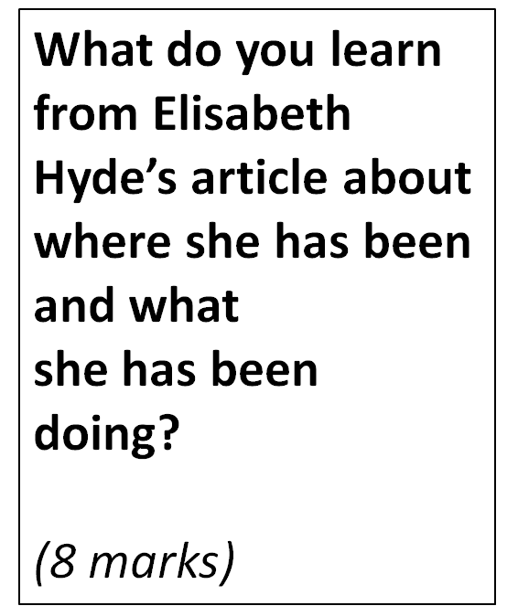
Sample response:
The first thing that the reader learns is that the guide, called Ed, gives them two rules which are both to stay in the boat. We later learn that Elizabeth violates these rules: “We hit one rapid at the wrong angle and the boat rose up and pretty much ejected me.” This sounds like a very scary experience but the reader later finds out about Elizabeth’s character, and that she was more exhilarated than scared.
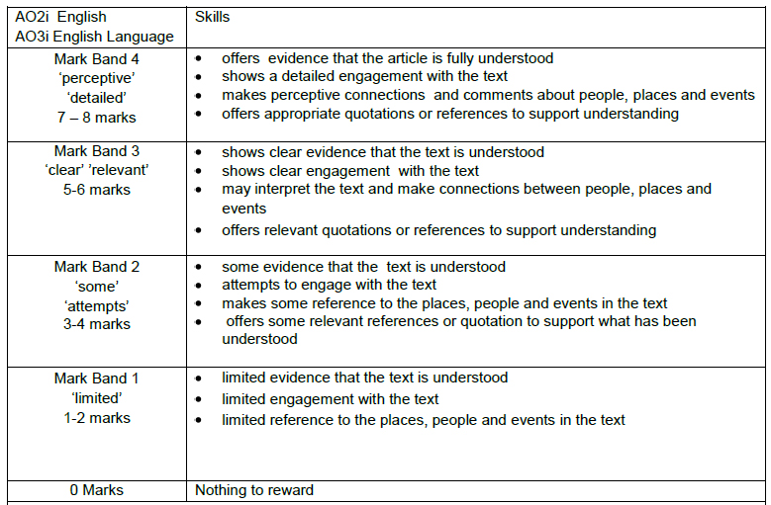
- Identify the three part structure in the response above. [WEE]
- How could the response above be improved?
- Try writing your own response to this question, using the mark scheme to help.

