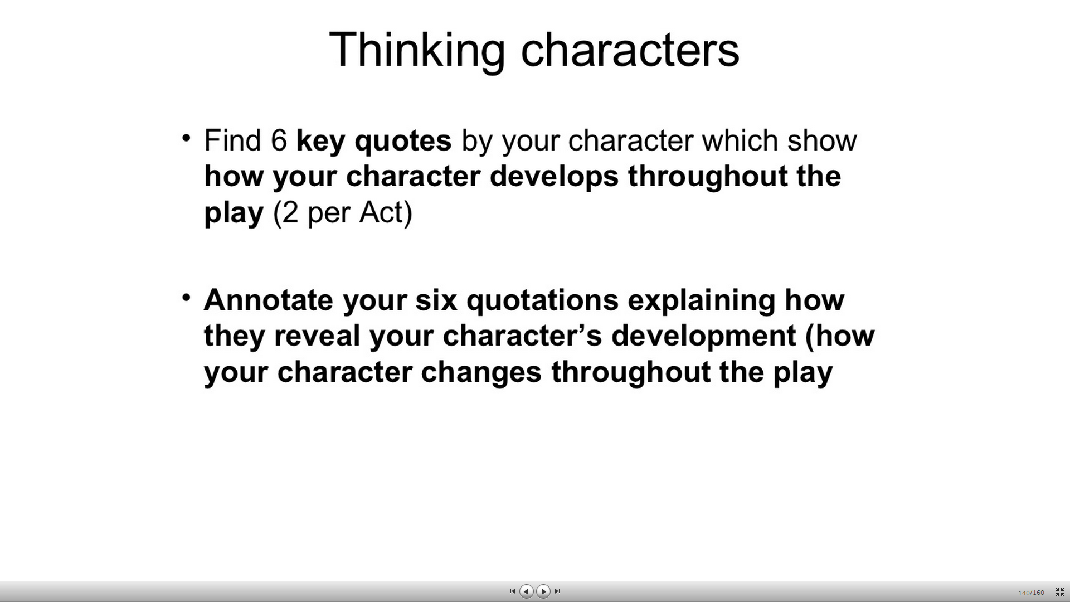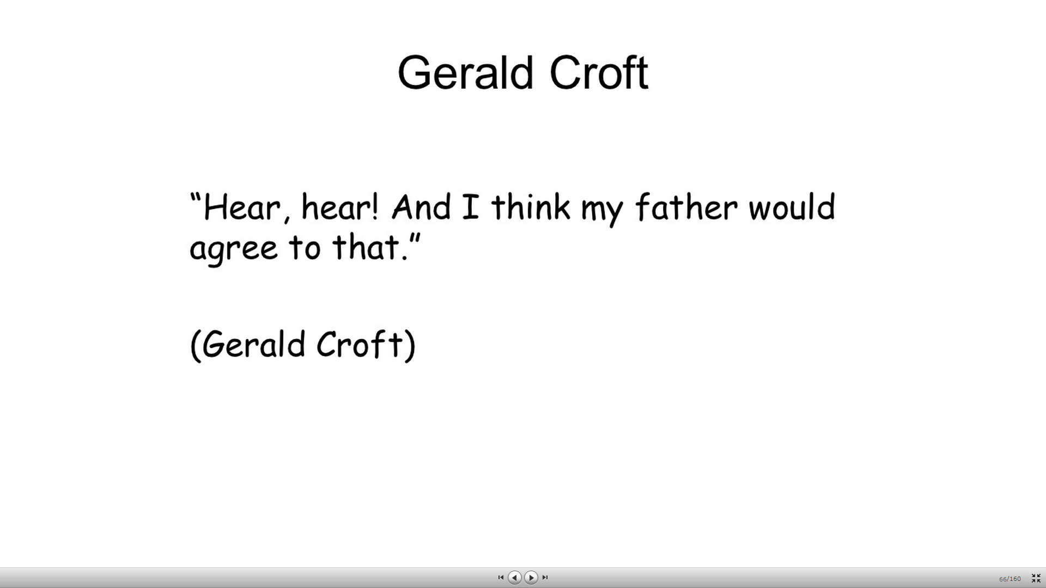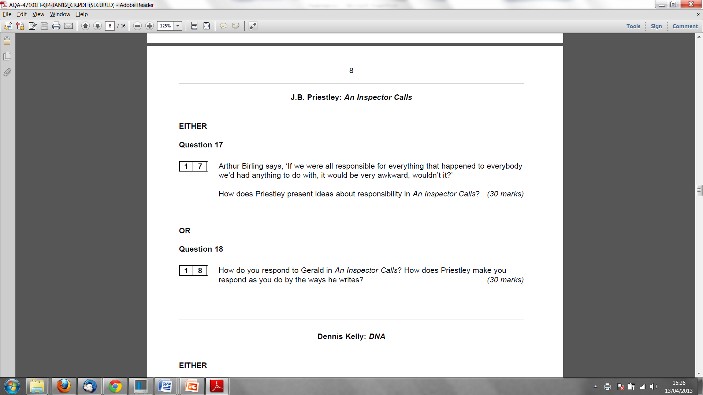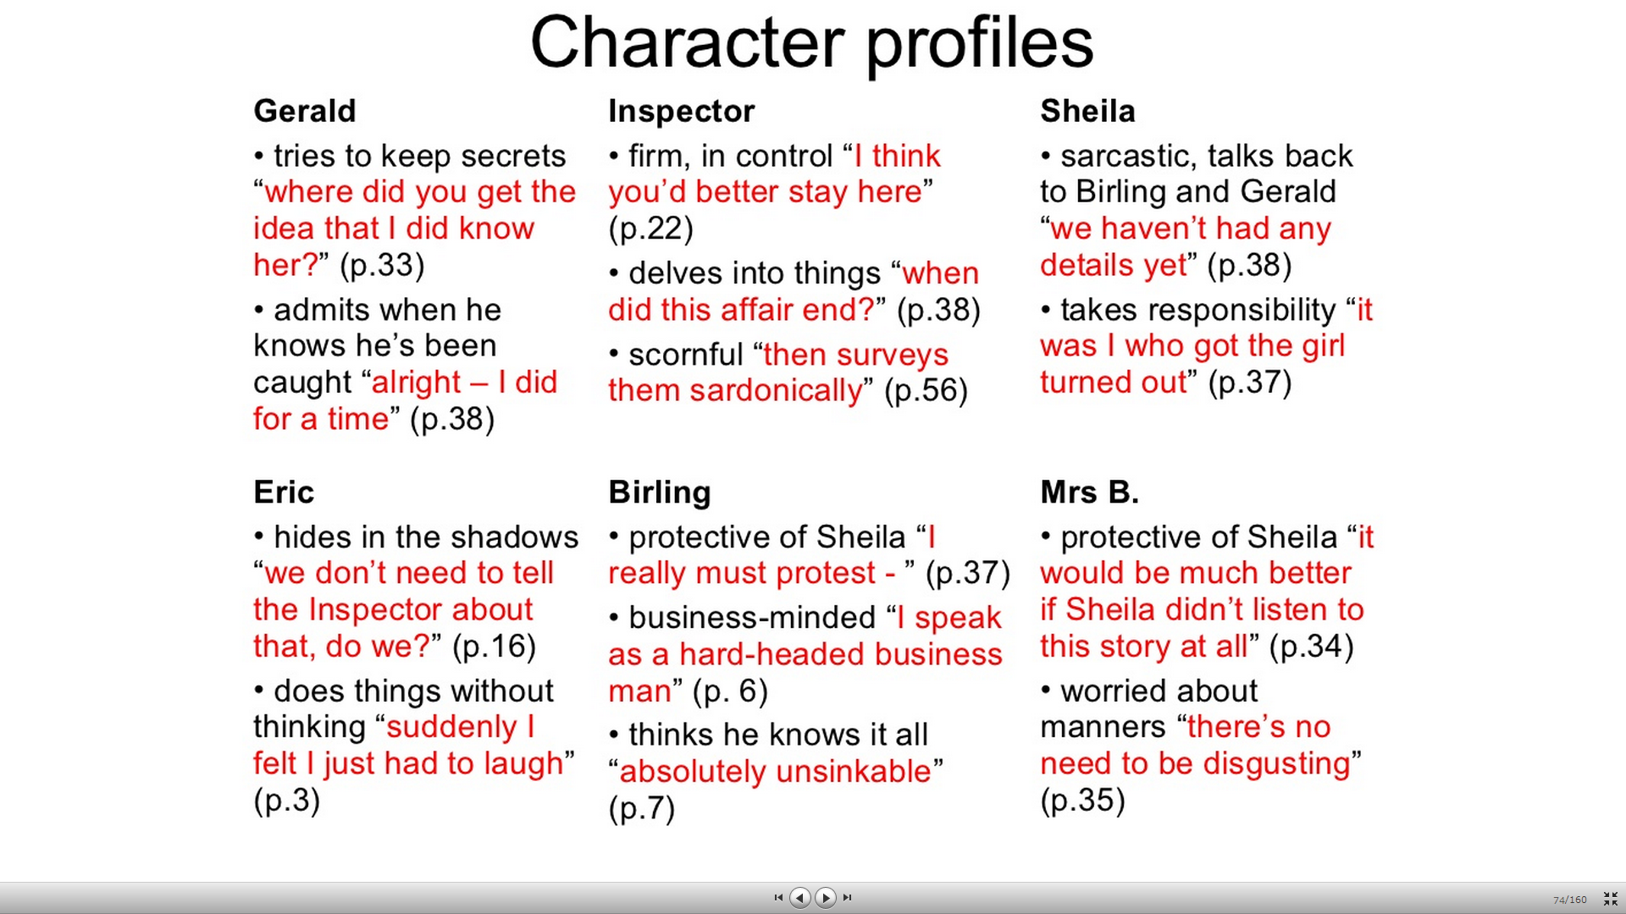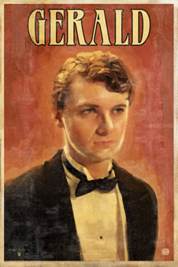

* **Bitesize:**
* He is described as "an attractive chap about thirty, rather too manly to be a dandy but very much the easy well-bred man-about-town."
* He is an **aristocrat** - the son of Lord and Lady Croft. We realise that they are not over-impressed by Gerald's engagement to Sheila because they declined the invitation to the dinner.
* He is not as willing as Sheila to admit his part in the girl's death to the Inspector and initially pretends that he never knew her. Is he a bit like Mr Birling, wanting to protect his own interests?
* He did have some genuine feeling for Daisy Renton, however: he is very moved when he hears of her death. He tells Inspector Goole that he arranged for her to live in his friend's flat "because I was sorry for her;" she became his mistress because"She was young and pretty and warm-hearted - and intensely grateful."
* Despite this, in Act 3 he tries to come up with as much evidence as possible to prove that the Inspector is a fake - because that would get him off the hook. It is Gerald who confirms that the local force has no officer by the name of Goole, he who realises it may not have been the same girl and he who finds out from the infirmary that there has not been a suicide case in months. He seems to throw his energies into "protecting" himself rather than"changing" himself (unlike Sheila).
* At the end of the play, he has not changed. He has not gained a new sense of social responsibility, which is why Sheila (who has) is unsure whether to take back the engagement ring.