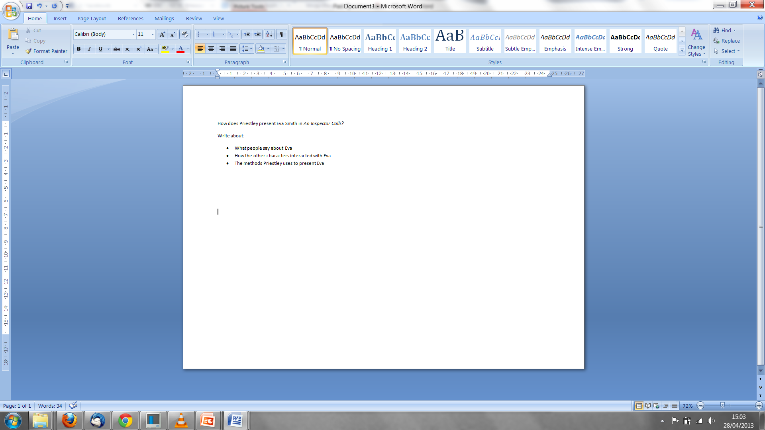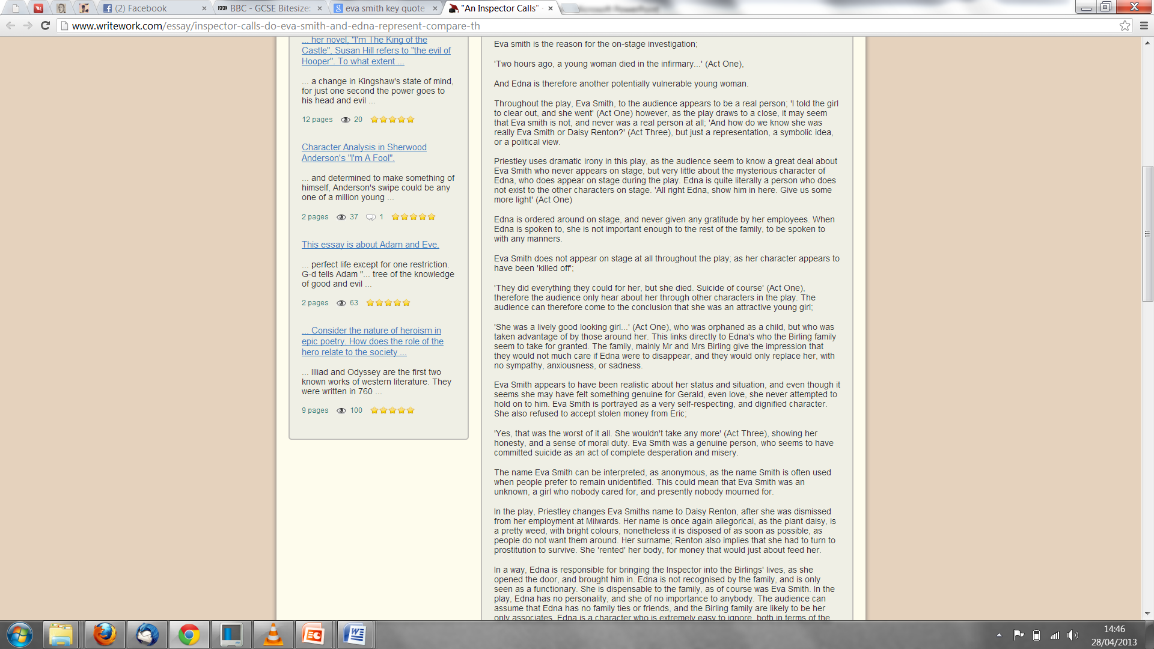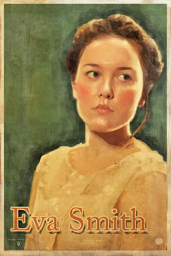

* **Bitesize:**

Of course, we never see Eva Smith on stage in the play: we only have the evidence that the Inspector and the Birlings give us.

* The Inspector, Sheila Gerald and Eric all say that she was "pretty." Gerald describes her as "very pretty - soft brown hair and big dark eyes."
* Her parents were dead.
* She came from outside Brumley: Mr Birling speaks of her being "country-bred."
* She was working class.
* The Inspector says that she had kept a sort of diary, which helped him piece together the last two years of her life:
* However, in Act 3 we begin to wonder whether Eva ever really existed. Gerald says, "We've no proof it was the same photograph and therefore no proof it was the same girl." Birling adds, "There wasn't the slightest proof that this Daisy Renton really was Eva Smith." Yet the final phone call, announcing that a police inspector is shortly to arrive at the Birlings' house to investigate the suicide of a young girl, makes us realise that maybe Eva Smith did exist after all. What do you think?
* Think about Eva's name. *Eva* is similar to *Eve*, the first woman created by God in the Bible. *Smith* is the most common English surname. So, *Eva Smith* could **represent** every woman of her class.
* Find 6 **key quotes** about your character which show **how our understanding of your character develops throughout the play** (2 per Act)
* **Annotate your six quotations explaining how they reveal how our understanding of your character changes throughout the play**

She was honest and had a sense of moral duty: 'Yes, that was the worst of it all. She wouldn't take any more' (Act Three)

She was attractive to people who would take advantage of her: 'She was a lively good looking girl...' (Act One)