BBC Bitesize:

J B Priestley
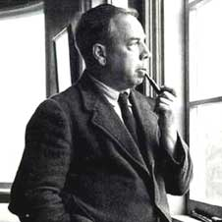
John Boynton Priestley was born in Yorkshire in 1894. He knew early on that he wanted to become a writer, but decided against going to university as he thought he would get a better feel for the world around him away fromacademia. Instead, he became a junior clerk with a local wool firm at the age of 16.
When the First World War broke out, Priestley joined the infantry and only just escaped death on a number of occasions. After the war, he gained a degree from Cambridge University, then moved to London to work as a freelance writer. He wrote successful articles and essays, then published the first of many novels, The Good Companions, in 1929. He wrote his first play in 1932 and went on to write 50 more. Much of his writing was ground-breaking and controversial. He included new ideas about possible parallel universes and strong political messages.
During the Second World War he broadcast a massively popular weekly radio programme which was attacked by the Conservatives as being too left-wing. The programme was eventually cancelled by the BBC for being too critical of the Government.
He continued to write into the 1970s, and died in 1984.

Political views
During the 1930's Priestley became very concerned about the consequences of social inequality in Britain, and in 1942 Priestley and others set up a new political party, the Common Wealth Party, which argued for public ownership of land, greater democracy, and a new 'morality' in politics. The party merged with the Labour Party in 1945, but Priestley was influential in developing the idea of the Welfare State which began to be put into place at the end of the war.
He believed that further world wars could only be avoided through cooperation and mutual respect between countries, and so became active in the early movement for a United Nations. And as the nuclear arms race between West and East began in the 1950s, he helped to found CND, hoping that Britain would set an example to the world by a moral act of nuclear disarmament.

1912 to 1945
This was the period of the Russian Revolution, two appalling world wars, the Holocaust and the Atom Bomb.

This table describes what society was like in 1912 and in 1945
An Inspector Callsis set in 1912 | An Inspector Calls was written in 1945. | Images
The First World War would start in two years. Birling's optimistic view that there would not be a war is completely wrong. | The Second World War ended in Europe on 8 May 1945. People were recovering from nearly six years of warfare, danger and uncertainty. | 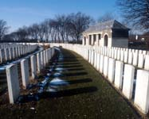
There were strong distinctions between the upper and lower classes. | Class distinctions had been greatly reduced as a result of two world wars. | 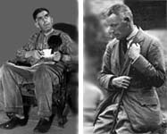
Women were subservient to men. All a well off women could do was get married; a poor woman was seen as cheap labour. | As a result of the wars, women had earned a more valued place in society. | 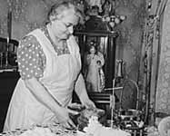
The ruling classes saw no need to change the status quo. | There was a great desire for social change. Immediately after The Second World War, Clement Attlee's Labour Party won a landslide victory over Winston Churchill and the Conservatives. | 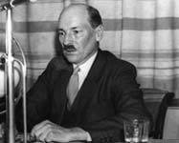
Priestley deliberately set his play in 1912 because the date represented an era when all was very different from the time he was writing. In 1912, rigid class and gender boundaries seemed to ensure that nothing would change. Yet by 1945, most of those class and gender divisions had been breached. Priestley wanted to make the most of these changes. Through this play, he encourages people to seize the opportunity the end of the war had given them to build a better, more caring society.

