Code of Chivalry and Being Chivalrous
The Code of Chivalry was a moral system which went beyond rules of combat and introduced the concept of Chivalrous conduct - qualities idealised by the Medieval knights such as bravery, courtesy, honour and great gallantry toward women. It also incorporated the notion of courtly love. The Code of Chivalry was the honour code of the knight. The Code of Chivalry was an important part of the society and lives of people who lived during the Medieval times and was understood by all.
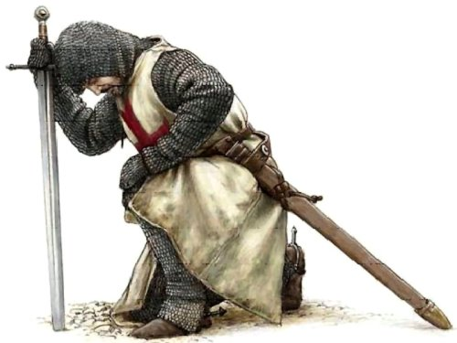
The Knight's Code of Chivalry
A knight was expected to have not only the strength and skills to face combat in the violent era of the Middle Ages but was also expected to temper this aggressive side with a chivalrous side to his nature. The ideals described in the Code of Chivalry were emphasised by the oaths and vows that were sworn in the Knighthood ceremonies of the Middle Ages and the Medieval era. These sacred oaths of combat were combined with the ideals of chivalry and with strict rules of etiquette and codes of conduct towards women.
Code of Chivalry described by the Duke of Burgundy
The chivalric virtues of the Code of Chivalry were also described in the 14th Century by the Duke of Burgundy. The words he chose to use to describe the virtues that should be exhibited in the Knights Code of Chivalry were as follows:
- Faith
- Charity
- Justice
- Prudence
- Resolution
- Truth
- Diligence
- Hope
- Valour

Although Macbeth is a warrior rather than a knight, he would still have been expected to act in a chivalrous fashion. Choose three of the virtues above and explain how Macbeth fails to show them.
1.

2.

3.

Code of Chivalry and Being Chivalrous
The Code of Chivalry was a moral system which went beyond rules of combat and introduced the concept of Chivalrous conduct - qualities idealised by the Medieval knights such as bravery, courtesy, honour and great gallantry toward women. It also incorporated the notion of courtly love. The Code of Chivalry was the honour code of the knight. The Code of Chivalry was an important part of the society and lives of people who lived during the Medieval times and was understood by all.
The Knight's Code of Chivalry
A knight was expected to have not only the strength and skills to face combat in the violent era of the Middle Ages but was also expected to temper this aggressive side with a chivalrous side to his nature. The ideals described in the Code of Chivalry were emphasised by the oaths and vows that were sworn in the Knighthood ceremonies of the Middle Ages and the Medieval era. These sacred oaths of combat were combined with the ideals of chivalry and with strict rules of etiquette and codes of conduct towards women.
Code of Chivalry described by the Duke of Burgundy
The chivalric virtues of the Code of Chivalry were also described in the 14th Century by the Duke of Burgundy. The words he chose to use to describe the virtues that should be exhibited in the Knights Code of Chivalry were as follows:
- Faith
- Charity
- Justice
- Prudence
- Resolution
- Truth
- Diligence
- Hope
- Valour

Although Macbeth is a warrior rather than a knight, he would still have been expected to act in a chivalrous fashion. Choose three of the virtues above and explain how Macbeth fails to show them.
1.

2.

3.

