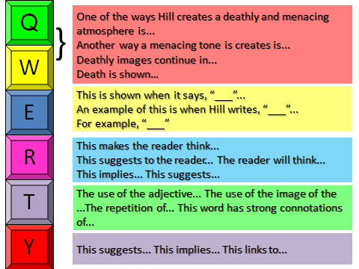
The Red Room
Q2. How does the writer use language to create a deathly and menacing atmosphere?

A narrow path led down between the yew trees into the small copse. That, and a field beyond it, was all that was now left of the Hooper land.
The boy’s room, high up at the back of the house, overlooked the copse. He had chosen it.
His father had said “ But look at all the others, so much larger and brighter.” But he had wanted this, a narrow room with a tall window. Above him, there were only the attics.
When he woke, now, there was an enormous moon, so that at first, he thought it was already dawn, and that he had missed his chance. He got out of bed. There was a slight, persistent movement of wind through the yew tree branches, and the elms and oaks of the copse, and a rustling of the high grasses in the field. The moonlight, penetrating a thin space between the trees, caught the stream that ran through its centre, so that, now and then, as the branches stirred, there was a gleam of water. Edmund Hooper looked down. The night was very warm.
Outside, on his landing, there was no moonlight, and he felt his way in the dark. He went forward quite deliberately, being sure of his way, and unafraid. There was no sound from the room where his father slept. Mrs Boland, the housekeeper, only came here during the day. Mrs Boland did not like Warings. It is too dark, she said, it smells unlived in, of old things, like a museum.
Hooper crossed the wide hall, and here too, because it was the front of the house, no moonlight came.
At first, he could not decide which key it might be. There were three together in then left-hand drawer. But one was longer, with a smudge of red paint across the rim. Red paint for the Red Room.
It was at the back of the house, facing the copse, so that when he pushed the door, he saw it in full moonlight, almost as bright as day, when the lights always had to go on, because of the yew branches, overhanging the windows.
Hooper stepped inside.
It had been designed by the first Joseph Hooper as a library and there were still glass cases, reaching from floor to ceiling, all around the room, filled with books. But nobody ever read, here.
Hooper stopped in front of a case at the far end of the room, beside the uncurtained window. He looked down at the flat, fragile shapes of the dead moths, laid out on white card, and at the labels beneath them. The names pleased him- hawk Moths, Footmen Moths, Lutestring Moths. He read some of them out to himself, in a low voice. Moonlight came through the window, coldly, on to the glass. Hooper was fascinated by them, excited. He inserted the small key and lifted up the glass lid. It was very heavy and stiff from disuse. A puff of old, stale-smelling air came into his face.
The largest moth of all was in the centre of the case. The ink of the card had faded to a dark yellow in the sun. ‘Death’s Head Hawk Moth’.
He stretched out his hand, put his finger under the head of the pin and slid it up, out of the thick, striped body. At once, the whole moth, already years dead, disintegrated, collapsing into a soft, formless heap of dark dust.

