‘I’m the King of the Castle’
Q1. Read the extract and then list four things you learn about the house.
The house, which was called Warings, had been built by the boy’s great-grandfather, and so it was not very old. In those days, there had been a large village, and the first Joseph Hooper had owned a great deal of land. Now, the village had shrunk, people had left for the towns and there had been few newcomers, few new buildings. Derne became like an old busy port which had been deserted by the sea. All the Hopper land had been sold off, piece by piece. But there was still Warings, built on a slope leading out of the village, some distance from any other house.
- ________________________________________________________________
- ________________________________________________________________
- ________________________________________________________________
- ________________________________________________________________
Q1. Continue to read and then list four things you learn about the first Joseph Hooper.
The first Joseph Hooper had been a banker, and rising in the world, when, at the age of thirty, he had built the house. “I am not ashamed of it,” he had told his friends in the City. And indeed, had spent more on it than he could well afford. He hoped to grow into it, as a child grows into overgrown shoes. He was an ambitious man. He had brought the younger daughter of a minor baronet here, as his bride, and set about founding his family, consolidating a position, so that he could afford the house he had built. He had succeeded with no margin, so that, bit by bit, the surrounding land which belonged to him had been sold.
- ________________________________________________________________
- ________________________________________________________________
- ________________________________________________________________
- ________________________________________________________________

Q2. Read the next part and circle any words or phrases that make the building seem strange and mysterious.
Warings was ugly. It was entirely graceless, rather tall and badly angled, built of dark red brick. At the front, and on both sides, there was the lawn, sloping downwards to a gravelled drive, and then into the lane, and without any tree or flower-bed to relieve the bald greenness. Up the drive, and at the back of the house, bunched between yew trees, were the great bushes of rhododendron.
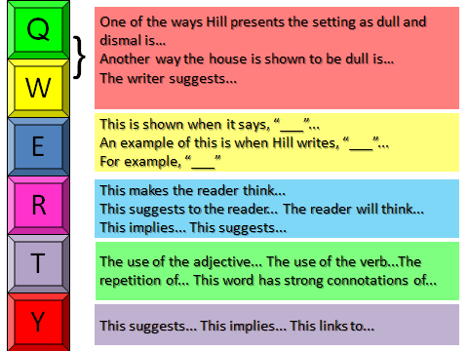
Q2. Looking at all of the extracts, how does the writer use language to create a dull, dismal setting?

____________________________________________________________________________________________________________________________________________________________________________________________________________________________________________________________________________________________________________________________________________________________________________________________________________________________________________________________________________________________________________________________________________________________________________________________________________________________________________________________________________________________________________________________________________________________________________________________________________________________________________________________________________________________________________________________________________________________________________________________________________________________________________________________________________________________________________________________________________________________________________________________________________________________________________________________________________________________________________________________________________________________________________________________________________________________________________________________

