What is the American Dream?
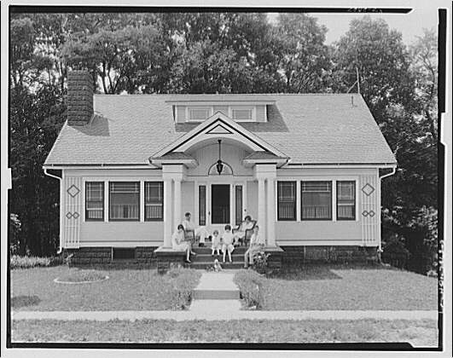
Read the following definition of the American Dream, from James Truslow Adams’ book, The Epic of America, which was written in 1931. He was the one to first use the term.

“The American Dream is that dream of a land in which life should be better and richer and fuller for everyone, with opportunity for each according to ability or achievement. It is not a dream of motor cars and high wages, but a dream of social order in which each man and each woman shall be able to achieve the fullest stature of which they are capable of, and be recognized by others for what they are, regardless of the circumstances of birth or position."

The ‘American Dream’ was a dream that in the land of America, everyone could achieve success through hard work and commitment, no matter what their background was like. The belief was founded on the lack of a clearly defined class system in America, when compared to a nation such as Great Britain, and also the sheer size of America. A person seeking fortune would be advised to ‘Go West’ and, due to the vast scale of the country, they would be able to find land there that they could work.

Of Mice and Men explores the problems with the ‘American Dream’. The Great Depression and the advent of the Dust Bowl made the lives of millions of ordinary people tough, and opportunities hard to come by.

- Do you think the American Dream is achievable? Why or why not? Write your ideas in your book.
- How do the dreams of the characters in ‘Of Mice and Men’ relate to the American Dream?

