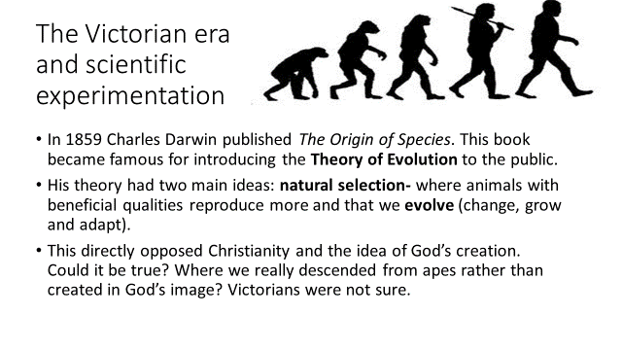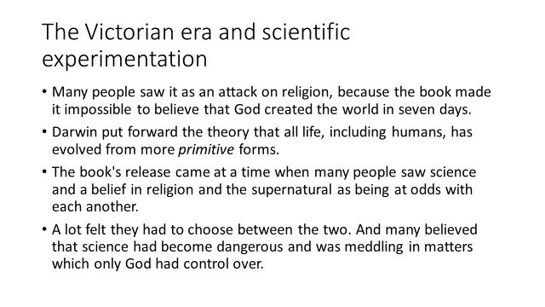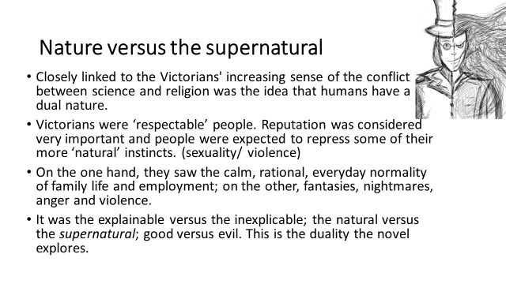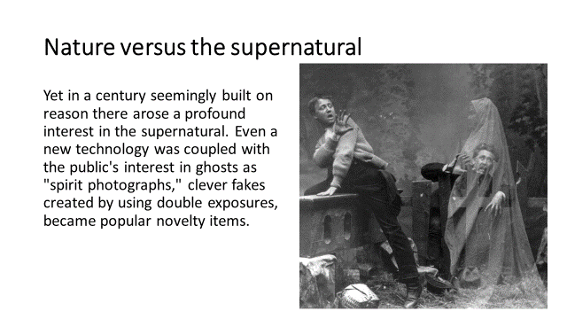
Victorian Attitudes:
Science was scary
People had two sides – one respectable and fair, the other mean and evil
If you couldn’t explain something, it was God’s work
It was important to hide some aspects of your personality and seem respectable at all times

