Writing about an Unseen Poem: The Eagle
The Eagle
He clasps the crag with crooked hands;
Close to the sun in lonely lands,
Ringed with the azure world he stands.

The wrinkled sea beneath him crawls;
He watches from his mountain walls.
And like a thunderbolt he falls.

Alfred, Lord Tennyson

What do you think the poet is saying about the eagle, and nature in general, and how does he present his ideas?

Planning your answer: think about the following aspects of the poem and jot down some answers to the questions. You have five minutes.
- What does the title make you think about?
- Who is the speaker and who is being addressed?
- What happens in the poem?
- Where is it set? Does this change? When is it set? Does this change?
- How is it arranged? When and why does the poet start a new stanza? Is there a regular rhythm? What is the rhyme scheme? Why has the poet used these?
- How does the poet use sounds? What sort of imagery is used? Is there anything interesting about the language? Can you recognise any poetic techniques? Why has the poet used these?
- What do you think the poem is really about? What is the poet’s attitude to his or her theme?
- How does the poem make you feel and what do you think of it?

Sample answer:
In this poem the poet writes about an eagle, who is looking down at the land and sea, waiting for his prey.
The poem is very short but powerful. It has two stanzas of three lines each. In the first the eagle stands on the mountain; in the second he sees something beneath and ‘falls’.
The focus is on the eagle. He seems to be the only living creature in the landscape. The eagle is in command of his surroundings. He is fierce and possessive. He ‘clasps’ the crag as if it belongs to him. The alliteration of the hard sounds in ‘clasp the crags with crooked hands’ adds to the sense of violence.
The eagle is personified and made to sound like a human being. Right at the start he is referred to as ‘he’ rather than ‘it’ and he is said to have ‘hands’, not claws as you would expect. The use of the word ‘lonely’ is also interesting: although it refers to the lands, it implies the eagle himself is lonely, perhaps saying something about the loneliness of the powerful.
The poet’s imagery makes the eagle sound like a king or a general. The mountain is described as being like a castle: ‘mountain walls’. His height ‘close to the sun’ also implies power. It reminds me of the story of Icarus, who flew too close to the sun and, because the sun melted the wax in his wings, fell to the earth.
When he swoops, it must be to attack an animal, although the poet does not say so. Here he is compared to a thunderbolt, which is powerful and violent. The ending is very sudden and mirrors the suddenness of the eagle’s attack.
The poem has a strong regular rhythm of four beats a line. The strength of the beat reflects the strength of the eagle. All three lines in each stanza rhyme, which is unusual. You might expect a fourth line. Having just three reflects the quickness of his actions.
The eagle is part of nature; the crag, the sun, the ‘azure sky’ and the sea are all described. He is part of its beauty but he also represents its power. The poet seems to be impressed not just by the beauty of nature but also by its power and violence.
Can you find the following?
Brief introduction, mentioning the subject of the poem.
Structure and content.
Language techniques and their effect.
Personal response and interpretation.
Form and structure.
Effective conclusion, discussing the poet’s attitude and focusing on the question.

Is this answer good enough for an A*? Look at the mark scheme overleaf. How could you improve it? Try writing your own, better answer.

Unit 2 Section B Mark Scheme

Mark Band 6  16-18 marks | In response to the task, candidates demonstrate:  - insightful exploratory response to ideas/themes  - close analysis of detail to support interpretation  - evaluation of writer’s uses of language and/or structure and/or form and effects on readers
Mark Band 5  13-15 marks | In response to the task, candidates demonstrate:  - exploratory response to ideas/themes  - analytical use of detail  - analysis of writer’s uses of language and/or structure and/or form and effects on readers
Mark Band 4  10-12 marks | In response to the task, candidates demonstrate:  - considered/qualified response to ideas/themes  - details linked to interpretation  - appreciation/consideration of writer’s uses of language and/or structure and/or form and effects on readers
Mark Band 3  7-9 marks | In response to the task, candidates demonstrate:  - sustained response to ideas/themes  - effective use of details to support interpretation  - explanation of effect(s) of writer’s uses of language and/or structure and/or form and effects on readers
Mark Band 2  4-6 marks | In response to the task, candidates demonstrate:  - explained response to ideas/themes  - details used to support a range of comments  - identification of effect(s) of writer’s choices of language and/or structure and/or form intended/achieved
Mark Band 1  1-3 marks | In response to the task, candidates demonstrate:  - supported response to ideas/themes  - comment(s) on details  - awareness of writer making choice(s) of language and/or structure and/or form
0 marks | - Nothing worthy of credit

How to Leave the World that Worships Should

Let faxes butter-curl on dusty shelves.
Let junkmail build its castles in the hush
of other people’s halls. Let deadlines burst
and flash like glorious fireworks somewhere else.
As hours go softly by, let others curse
the roads where distant drivers queue like sheep.
Let e-mails fly like panicked, tiny birds.
Let phones, unanswered, ring themselves to sleep.
Above, the sky unrolls its telegram,
immense and wordless, simply understood:
you’ve made your mark like birdtracks in the sand -
now make the air in your lungs your livelihood.
See how each wave arrives at last to heave
itself upon the beach and vanish. Breathe.

Ros Barber

What do you think is the poet’s attitude towards the way we live and work in the modern world, and how does she present this attitude to the reader?

Have a go at writing an answer to this question. You have 30 minutes. After you have completed the question have a go at assessing it, using the mark criteria.
- Have you explored the poem, showing insight?
- Have you closely analysed details in the poem to support your interpretation?
- Have you evaluated the poet’s use of language and its effect on the reader?
- Have you evaluated the poet’s use of structure and form and their effect on the reader? Have you given a convincing and/or imaginative interpretation of the poem’s themes and ideas?

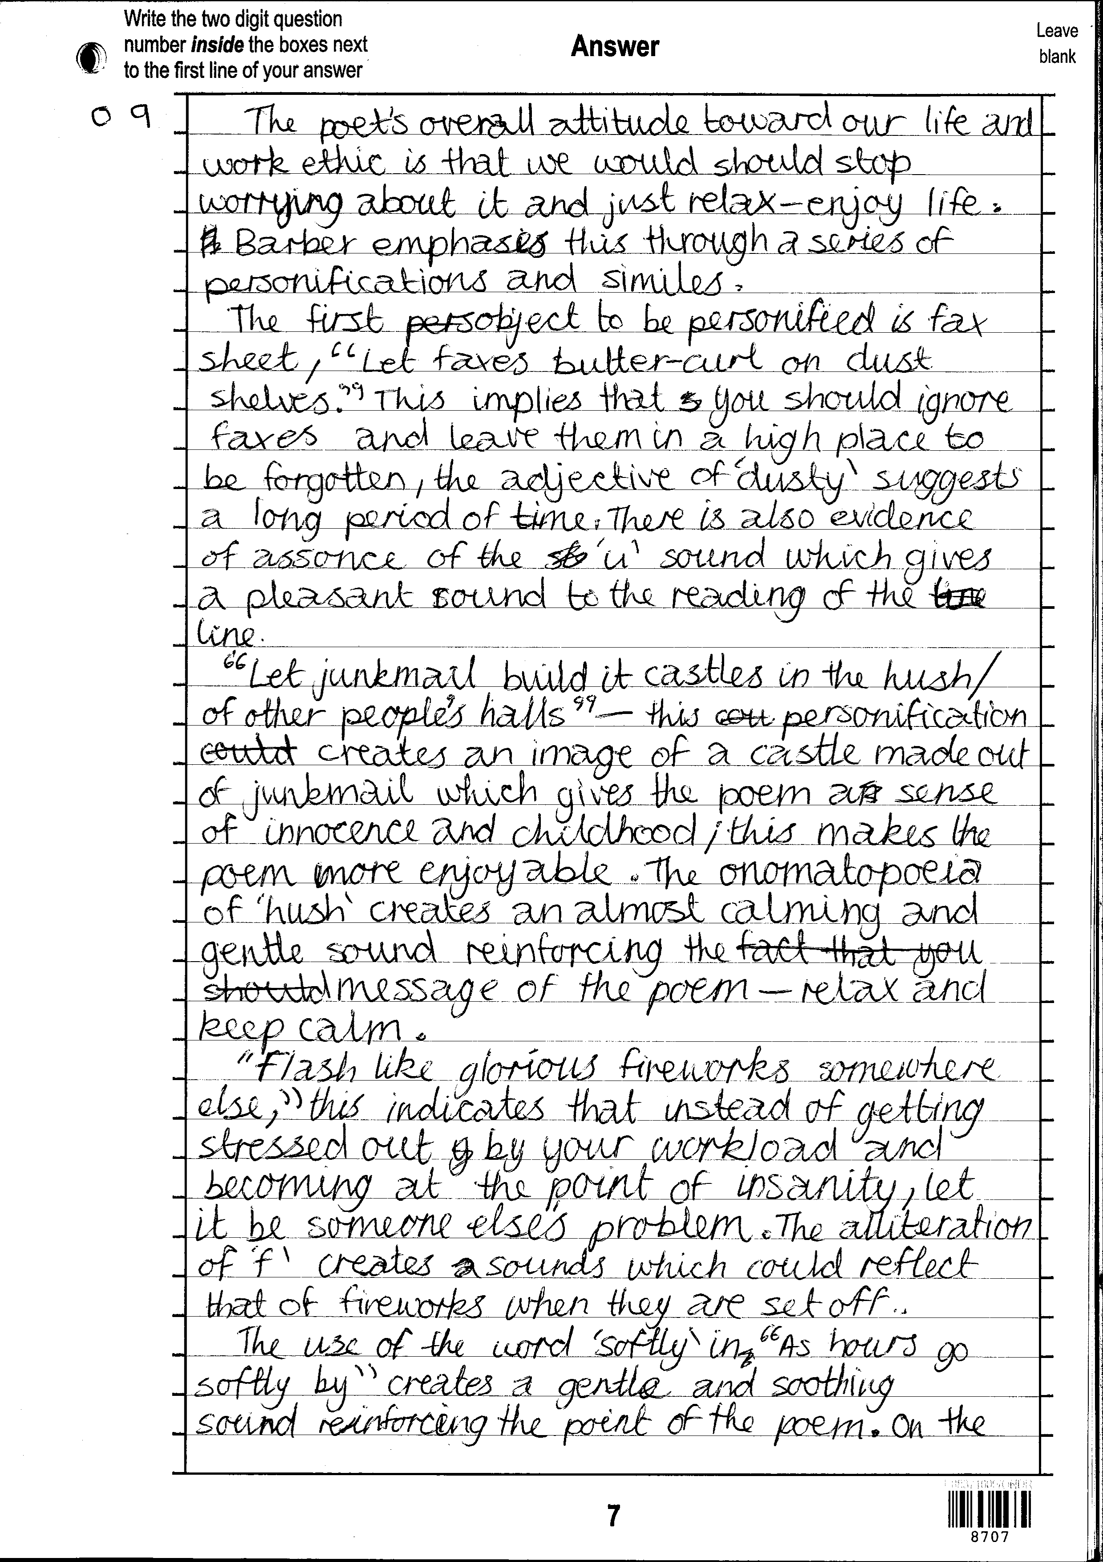

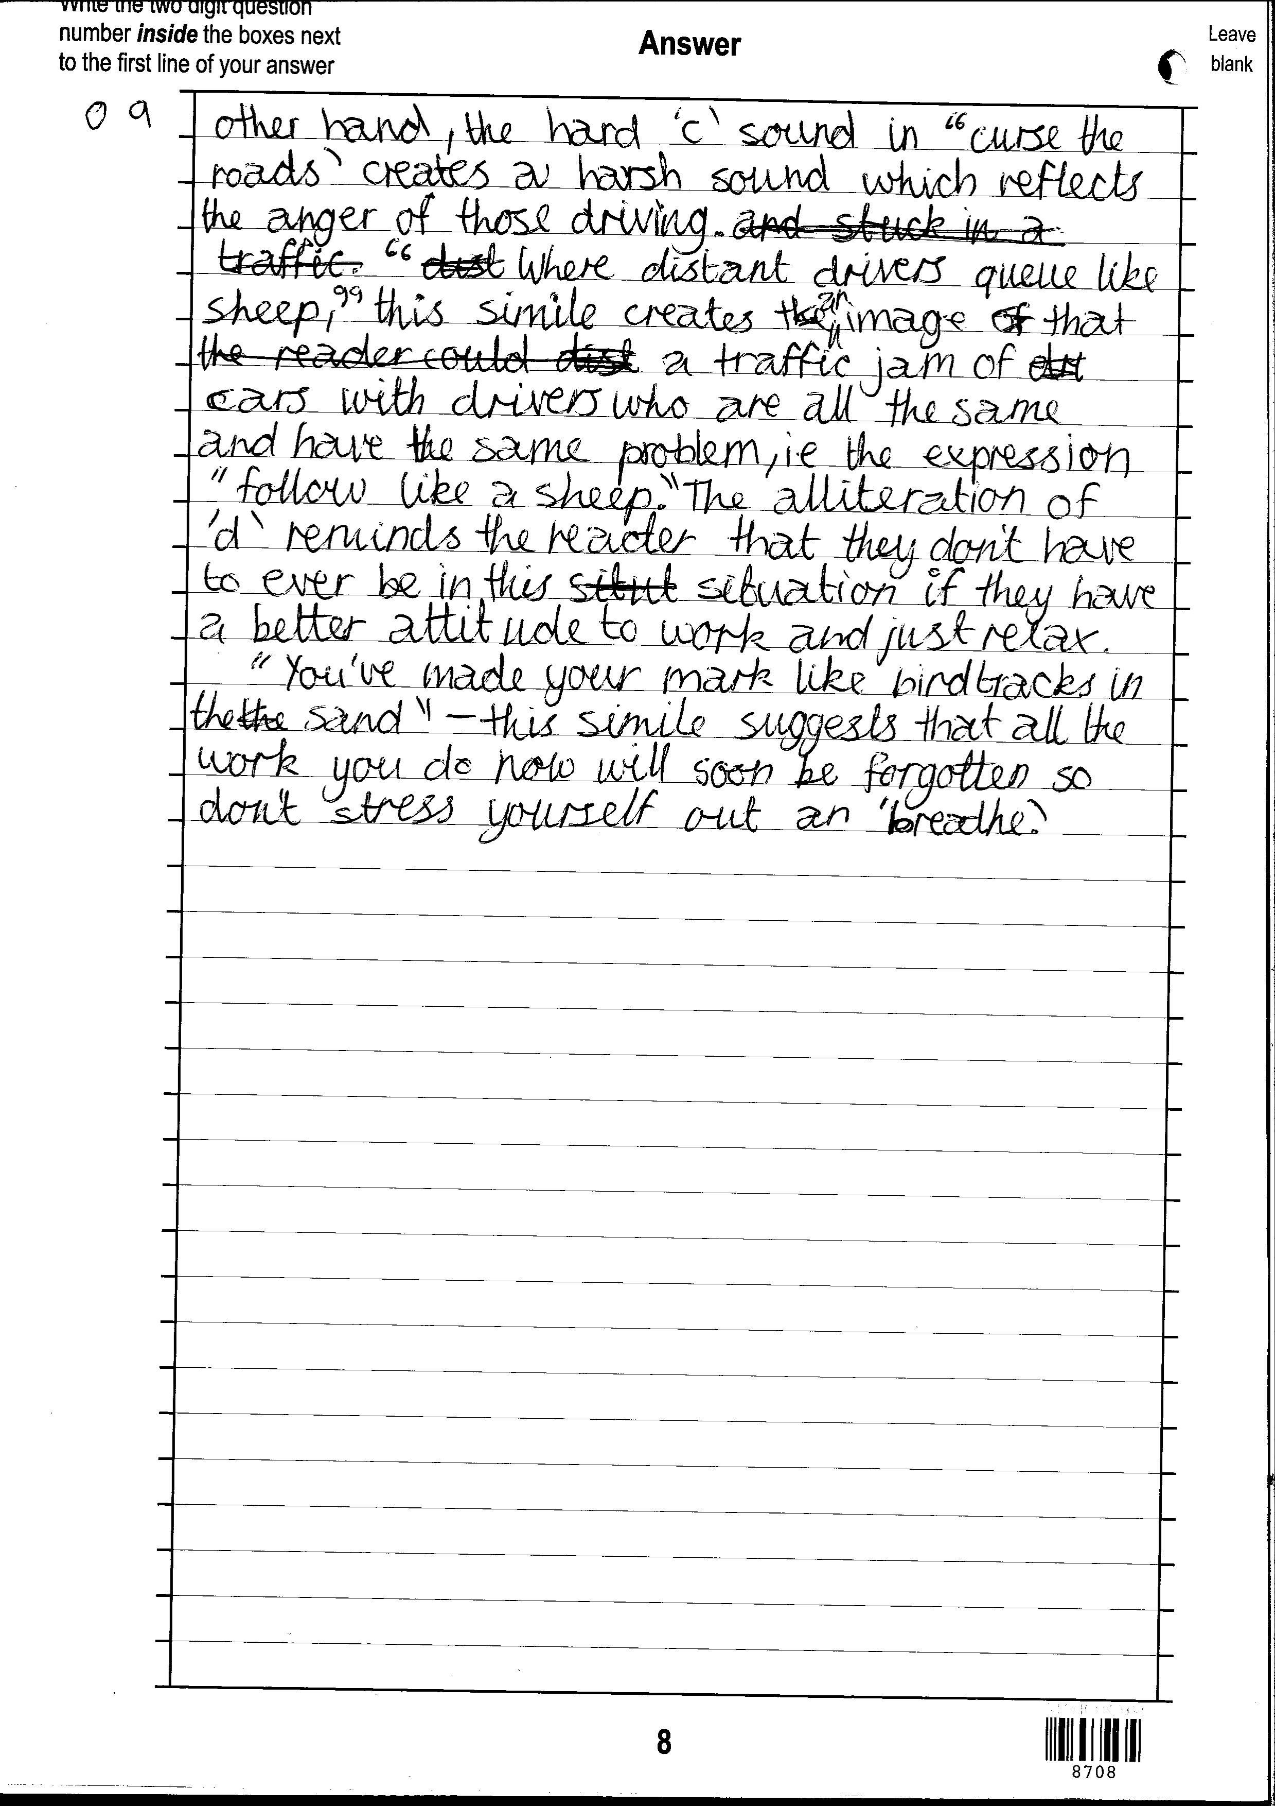
‘You’ve made your mark like bird tracks in the sand’ – this simile suggests that all the work you do now will soon be forgotten so don’t stress yourself out and ‘breathe’.
What could you add to this sentence to lift it into a higher band?

