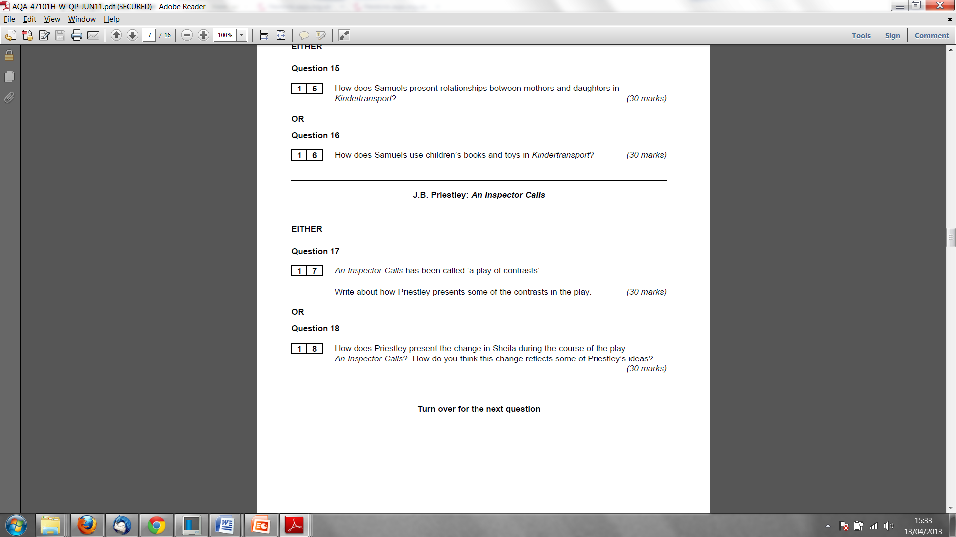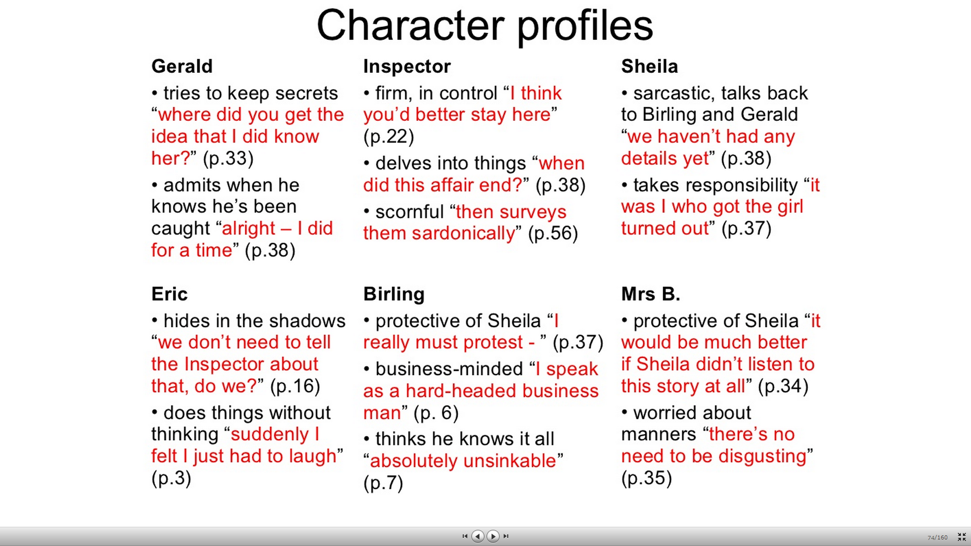

* **Bitesize:**
* She is described at the start as "a pretty girl in her early twenties, very pleased with life and rather excited."
* Even though she seems very playful at the opening, we know that she has had suspicions about Gerald when she mentions "last summer, when you never came near me." Does this suggest that she is not as naive and shallow as she first appears?
* Although she has probably never in her life before considered the conditions of the workers, she shows her **compassion**immediately she hears of her father's treatment of Eva Smith: "But these girls aren't cheap labour - they're people."Already, she is starting to change.
* She is horrified by her own part in Eva's story. She feels full of **guilt** for her jealous actions and blames herself as "really responsible."
* She is very **perceptive**: she realises that Gerald knew Daisy Renton from his reaction, the moment the Inspector mentioned her name. At the end of Act II, she is the first to realise Eric's part in the story. Significantly, she is the first to wonder who the Inspector really is, saying to him, 'wonderingly', "I don't understand about you." She warns the others "he's giving us the rope - so that we'll hang ourselves" (Act II) and, near the end, is the first to consider whether the Inspector may not be real.
* She is **curious.** She genuinely wants to know about Gerald's part in the story. It's interesting that she is not angry with him when she hears about the affair: she says that she respects his honesty. She is becoming **more mature.**
* She is **angry** with her parents in Act 3 for trying to "pretend that nothing much has happened." Sheila says "It frightens me the way you talk:" she cannot understand how they cannot have learnt from the evening in the same way that she has. She is seeing her parents in a new, unfavourable light.
* At the end of the play, Sheila is much **wiser.** She can now judge her parents and Gerald from a new perspective, but the greatest change has been in herself: her social conscience has been awakened and she is aware of her responsibilities. The Sheila who had a girl dismissed from her job for a trivial reason has vanished forever.