Mock Exam Preparation – Unit 1: Understanding and Producing Non Fiction Texts
Section A Question 4:
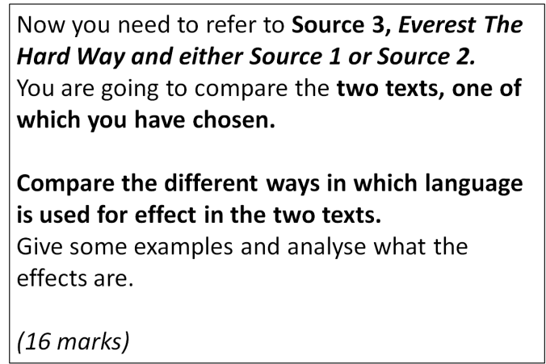
1. How effective is the below response? Identify places where the answer: a) comments on audience/purpose; b) compares the two texts.
2. Try writing your own response to this question, using the mark scheme to help. [QWERTY]

Sample response:
Source 1 and Source 3 are both documenting extreme journeys. However, the mood and the way they present their thoughts and feelings are very different. Source 1 has a more mainstream audience, perhaps travel writers or extreme sports enthusiasts. This means that the language used has to be accessible and more informal, so Hyde uses words like ‘gear’ to describe the equipment used and ‘a Disneyland-like experience’ which could appeal to a wider range of people and not just to those who know a lot about over-rafting. Source 3, however, uses many more words specific to the sport: ‘South Cal’; ‘runnels of ice’. The audience of this piece is different. They may be readers who would be interested in and more knowledgeable of mountaineering, therefore the writer has used more specialist language.
Emotive language and a series of questions are used in Source 1 to convey the writer’s feelings and engage the reader: ‘Was I scared? A little. Exhilarated? More than I’d ever been.’ The writer is clearly positive about her experience and the word ‘exhilarated’ indicates this. In this case, the questions are used to show the reader’s potential reaction and how life-changing the experience was. Questions are also used in Source 3 but this time they show very different emotions. In Source 3 we might begin to see the writer’s panic and disorientation through his use of the question ‘were we in the gully?’. This question could suggest...

