Macbeth Recap
Instructions: Roll the dice to choose a column. Roll again to decide the row. Answer. Your name will be put in the Square. Person with the most points wins!
 |  | 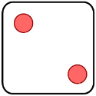 | 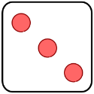 | 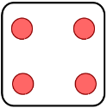 | 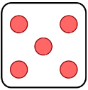 | 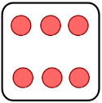
 | 1. When was Macbeth Written and by whom? | 2. In Act 1 Scene 3, what is Macbeth’s reaction to the witches’ prophecies? | 3. Who was the King when Macbeth was written? | 4. How is ambition presented in the play? | 5. Witches: “Fair is ___ and ___ is fair.” | 6. Lady McB: Look like th’ _________ ______, but be the ______ _______’
 | 7.Give 1 quote from Macbeth | 8. When and where was the play set? | 9.List all of the main characters in Macbeth | 10. What prophecies is Macbeth given in Act 1 Scene 3? | 11. What technique is used when the audience know that Macbeth will be Cawdor before him? | 12. Macbeth: “Full of _________ is my _____ dear wife.”
 | 13. Give one quote from Lady Macbeth | 14. What is Macbeth’s Hamartia? (Tragic Flaw) | 15. What 5 words would you use to describe Macbeth? | 16. Macbeth: “Is this a _______ I see before me?” | 17. Lady Macbeth: “Come, your ______, ______ me now.” | 18. Witches: Something ______ this way comes.”
 | 19. How does Lady Macbeth change within the play | 20. What do all the hallucinations represent in the play? Can you give an example? | 21. How does Macbeth change throughout the play? | 22. The weather when the witches are on stage is poor. What technique is this? | 23. What 5 words would you use to describe Lady Macbeth? | 24.What is the significance of the Gunpowder plot to Macbeth?
 | 25. Lady Macbeth: “Out ______ ____, out I ___!” | 26.What was the belief in the divine order? | 27. What did James I think about witches and what was his book called? | 28. Macbeth: “Be innocent of the _______, dearest _____.” | 29. Who in the play is “not of a woman born”? | 30. What are the witches’ apparitions in Act 4 Scene 1?
 | 31. What is a soliloquy? Give an example of when it is used in the play. | 32. Which characters speak in rhyme? Why? | 33. Malcolm: “This dead ______ and his ____ like queen.” | 34. Macbeth: Will all great ________’s ocean wash this _____ from my hand? | 35.What is the significance of sleep and darkness in the play? | 36. Lady Macbeth: “That which hath made them drunk hath made me _____”

