J & H Recap
Instructions: Roll the dice to choose a column. Roll again to decide the row. Answer. Your name will be put in the Square. Person with the most points wins!
 | 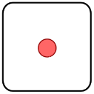 | 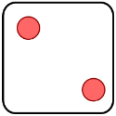 | 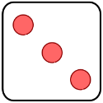 | 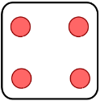 | 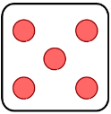 | 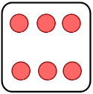
 | 1. When was Jekyll and Hyde written and by whom? | 2. In Chapter 1, was story does Enfield tell Utterson? | 3. How does Darwin’s theory of evolution link to the novella? | 4. How is the theme of Duality presented in the novella? | 5. Mr Hyde was “Pale and ________, he gave the impression of ________” | 6. The man “_______ calmly over the child’s ____ and left her screaming.”
 | 7.Give 1 quote about Lanyon | 8. When and where was the novella set? | 9.List all of the main characters in Jekyll and Hyde | 10. “If he shall be  Mr ____, I shall be Mr ____.” | 11. What narrative form is the majority of the novella told from? | 12. Hyde has ______’s signature on his face.”
 | 13. Give one quote about how Hyde kills Sir Danvers Carew. | 14. “man is not truly ____, but truly ___.” | 15. What 5 words would you use to describe Jekyll? | 16. Explain what Pathetic fallacy is and how it is used in the novella. | 17. What narrative form is used in chapters 9 and 10? | 18. How does Stevenson present the theme of secrecy?
 | 19. How does Jekyll change within the novella? | 20. What does Stevenson’s use of darkness and light symbolise? | 21. How does Lanyon change throughout the novella? | 22. The women in the novella are nameless. What does this suggest about their role in society? | 23. What 5 words would you use to Hyde? | 24. What is the name of chapter 4?
 | 25. Utterson is a man of “______ countenance, that was never ______ by a _______.” | 26. What 5 words would you use to describe Utterson? | 27. What is the name of chapter 6? | 28. Jekyll in chapter 3: “The moment I choose, I can be ___ of Mr _____.” | 29. What colour is used by Stevenson to depict Carew? What is the significance? | 30. How is the theme of secrecy explored through the ‘incident of the letter’?
 | 31. Jekyll in ch.7 is described as a ‘disconsolate ________’. | 32. What stipulations are made in Jekyll’s original will? | 33. Who calls whom an “ignorant, blatant pedant, and why?” | 34. What is the role of science and medicine in the novella? | 35. Jekyll: “If I am the chief of ______, I am the chief of __________ too.” | 36. Give an example of animal imagery used within the novella.

