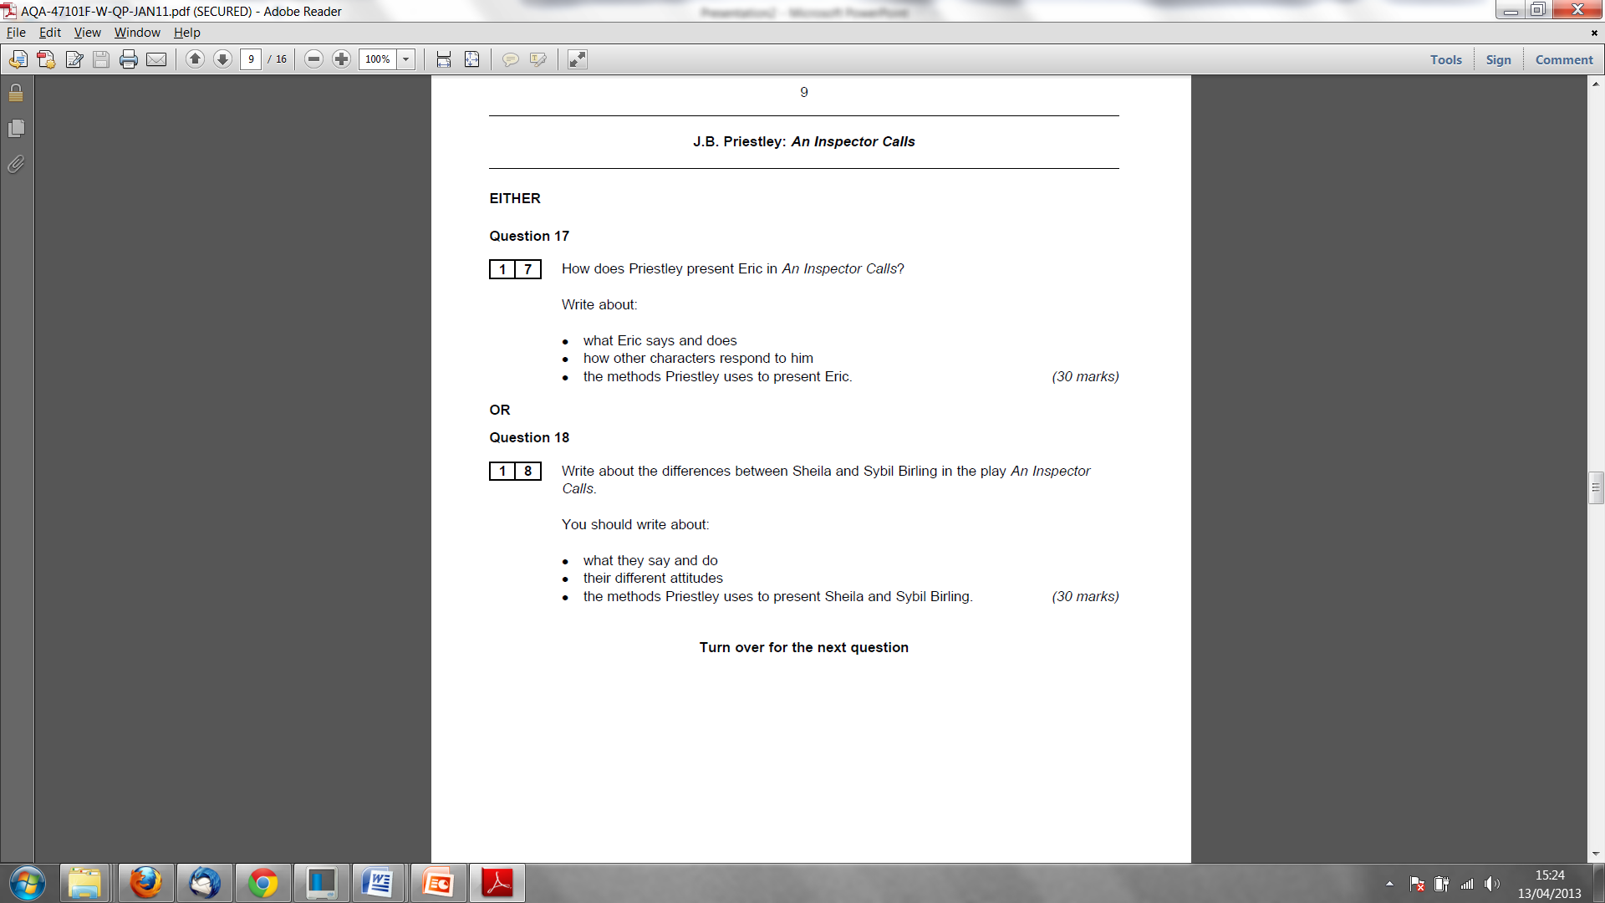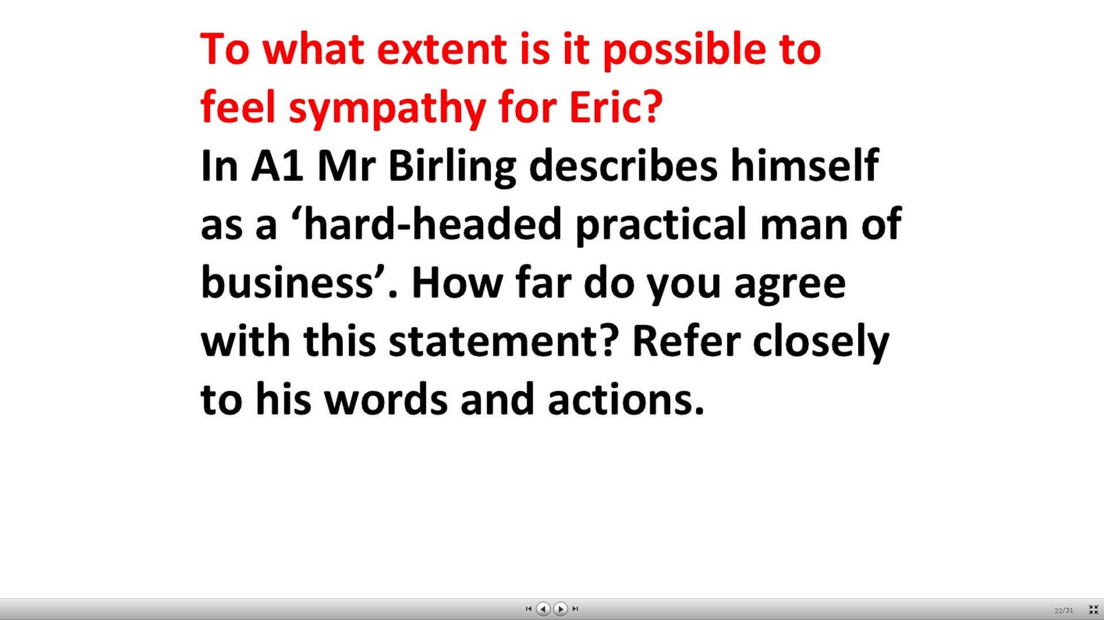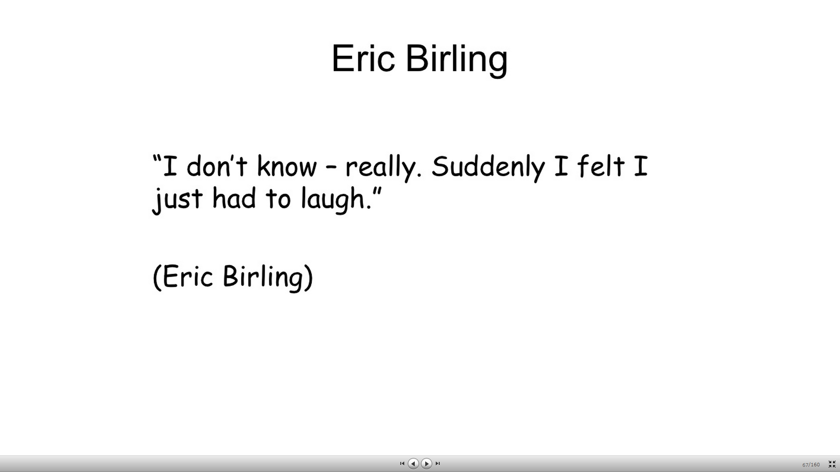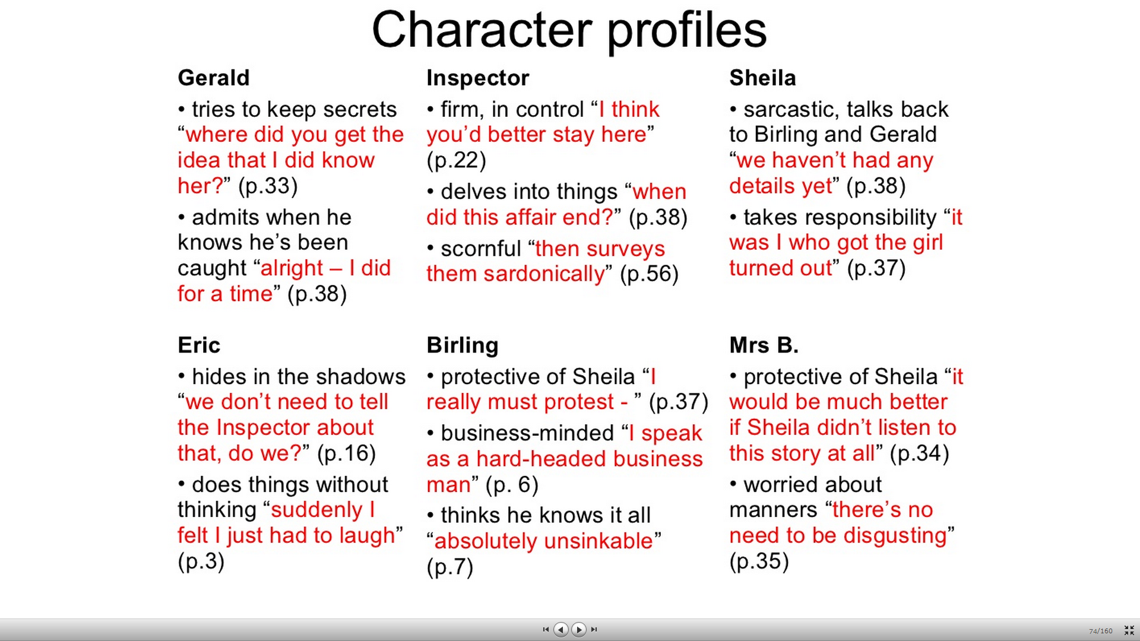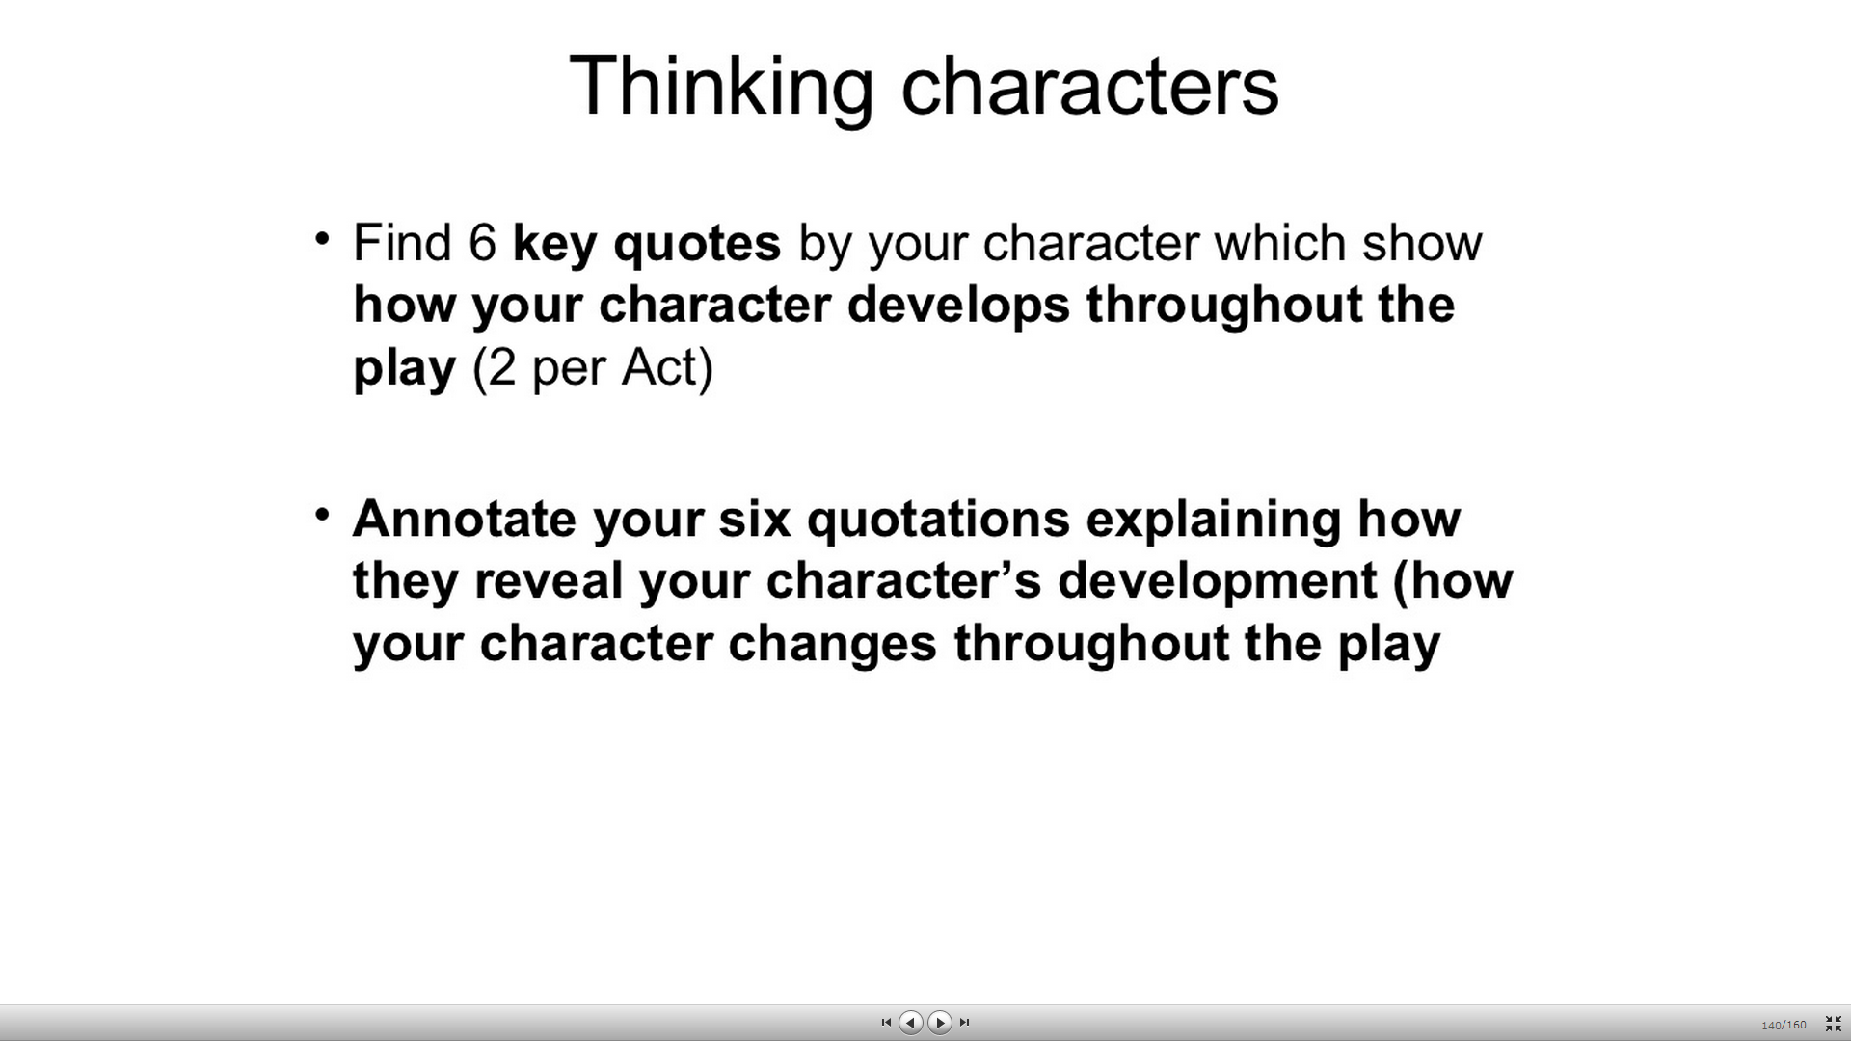

* **Bitesize:**
* He is described at the start as "in his early twenties, not quite at ease, half shy, half assertive."
* Eric seems **embarrassed and awkward**right from the start. The first mention of him in the script is "Eric suddenly guffaws," and then he is unable to explain his laughter, as if he is nervous about something. (It is not until the final act that we realise this must be because of his having stolen some money.) There is another awkward moment when Gerald, Birling and Eric are chatting about women's love of clothes before the Inspector arrives. Do you feel that there is tension in Eric's relationship with his father?
* It soon becomes clear to us (although it takes his parents longer) that he is a**hardened drinker**. Gerald admits, "I have gathered that he does drink pretty hard."
* When he hears how his father sacked Eva Smith, he supports the worker's cause, like Sheila. "Why shouldn't they try for higher wages?"
* He feels **guilt and frustration** with himself over his relationship with the girl. He cries, "Oh - my God! - how stupid it all is!" as he tells his story. He is horrified that his thoughtless actions had such consequences.
* He had some innate **sense of responsibility**, though, because although he got a woman pregnant, he was concerned enough to give her money. He was obviously less worried about stealing (or 'borrowing' from his father's office) than he was about the girl's future. So, was Eric, initially, the most socially aware member of the Birling family?
* He is appalled by his parents' inability to admit their own responsibility. He tells them forcefully, "I'm ashamed of you." When Birling tries to threaten him in Act III, Eric is aggressive in return: "I don't give a damn now." Do you think Eric has ever stood up to his father in this way before?
* At the end of the play, like Sheila, he is fully aware of his social responsibility. He is not interested in his parents' efforts to cover everything up: as far as he is concerned, the important thing is that a girl is dead. "We did her in all right."