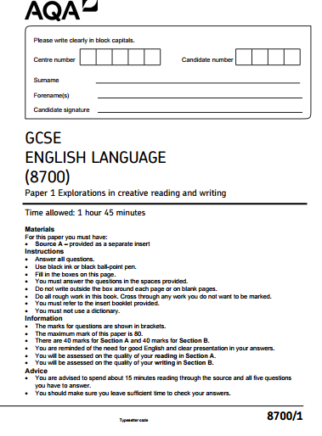

Section A: Reading
Answer all questions in this section.
You are advised to spend about 45 minutes on this section.

Q1: Read again the first part of the source, lines 1 to 4.

List four things from this part of the text about Mr Jones [4 marks]

1.__________________________________________________________________
2. _________________________________________________________________
3. _________________________________________________________________
4. _________________________________________________________________

Q2. Look in detail at this extract from lines 5 to 15 of the source:
As soon as the light in the bedroom went out there was a stirring and an uttering all through the farm buildings. Word had gone round during the day that old Major, the prize Middle White boar, had had a strange dream on the previous night and wished to communicate it to the other animals. It had been agreed that they should all meet in the big barn as soon as Mr. Jones was safely out of the way.
Old Major (so he was always called, though the name under which he had been exhibited was Willingdon Beauty) was so highly regarded on the farm that everyone was quite ready to lose an hour's sleep in order to hear what he had to say. At one end of the big barn, on a sort of raised platform, Major was already ensconced on his bed of straw, under a lantern which hung from a beam. He was twelve years old and had lately grown rather stout, but he was still a majestic- looking pig, with a wise and benevolent appearance in spite of the fact that his tushes had never been cut. Before long the other animals began to arrive and make themselves comfortable after their different fashions.

How does the writer use language here to present Old Major as an important animal on the farm?
You could include the writer’s choice of:
- words and phrases
- language features and techniques
- sentence forms [8 marks]
Q3. You now need to think about the whole of the source.

How has the writer structured the text to interest you as a reader?
You could write about:
• what the writer focuses your attention on at the beginning
• how and why the writer changes this focus as the extract develops
• any other structural features that interest you. [8 marks]

Q4. Focus this part of your answer on the whole of the source.
A student having said this section said, ‘This part of the novel makes me think that Old Major is really respected and the other animals think he is really persuasive.’
To what extent do you agree?
In your response, you could:
- write about your own impressions of Old Major
- evaluate how the writer has created the impressions that Old Major is persuasive and respected by the animals on the farm
- support your opinions with quotations from the text.
[20 marks]

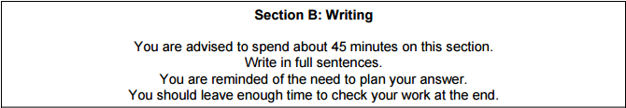

Your school or college is asking students to contribute some creative writing for its website.

Either: Write a description suggested by this picture:
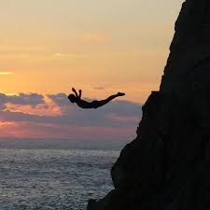

Or:
Describe an occasion when you felt sure or confident. Focus on the thoughts and feelings you had at that time.
(24 marks for content and organisation 16 marks for technical accuracy)
[40 marks]

