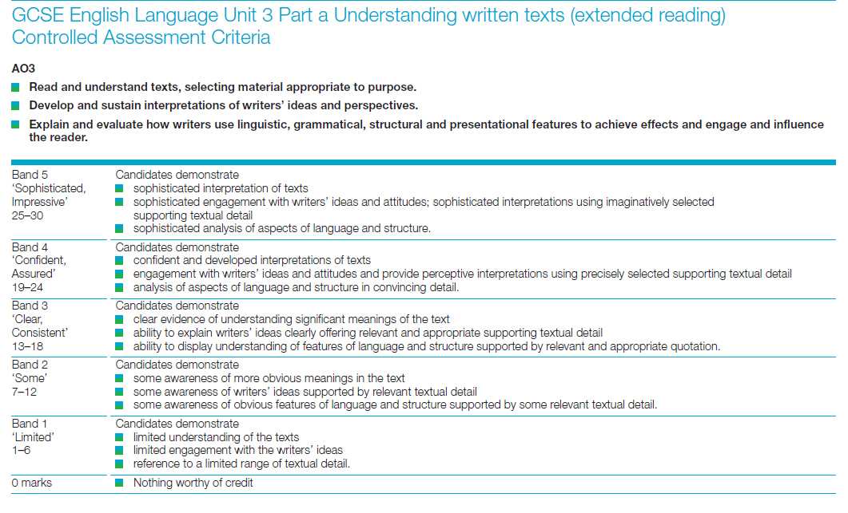

**Duration: up to 4 hours**

**Up to approx 1200 words (about 4-5 sides)**

**Essay plan:**

Use your notes from the tasks above to help write your notes.

**Introduction – a brief overview of the play.**

* What do you think the play is about?
* What is Priestley trying to get across to the audience?
* Why might he have these concerns?

**Main – how Priestley uses the Inspector to express his ideas about society .**

**Purpose. Ideas. Quotes. Analysis.**

1. *How is the theme of conflict introduced by the Inspector’s arrival?* Comment on presentational techniques used here to create drama and interest the audience. How does this help to convey the writer’s ideas?
2. *Explore how the Inspector treats Sheila during her interview.* How is language used to control the ‘interview’? Include quotes from the scenes you annotated and explain the effect. How does the audience respond to each character – and why? How is the action organised so that the Inspector remains in control? Why does the Inspector treat her this way? What does it tell us about Priestley’s ideas about society? Give examples and explain how it works.**\***
3. *Explore how the Inspector treats Mrs Birling during her interview.* Again, analyse how language is used by both characters and explore the effect. How does the conflict of this scene help us understand Priestley’s ideas about society? How does the audience respond to each character and why? How is the action organised? **\***
4. *Explore the conflict that exists and that is emphasised between Sheila and Mrs Birling.* Give specific examples but also think about what it symbolises (youth/age, child/parent). * How has Priestley used the Inspector to create this conflict? What does this tell us about Priestley’s ideas about society and the future?

5. *How does the Inspector’s final speech create a conflict between Mr Birling’s belief system and that of the**Inspector/JB Priestley?* What effect does the conflict between these two belief systems have on the audience? What does it tell us about Priestley’s ideas about society?

**\***In each of the sections looking at conflict between characters, you should look at the words that are used and the types of questions used. What effect do they have? How does the Inspector respond to what the characters say? Does the way he responds change at all? What emotions are displayed? What information do we gain from the stage directions? Most importantly, you must link these ideas to the way the Inspector represents Priestley’s ideas about society. What is he trying to show the audience?

**Conclusion – who is the Inspector?**

* What is the significance of the stage directions describing the Inspector?
* What does the Inspector’s name suggest about his role in the play? How does this add to our understanding of Priestley’s ideas about society and the Inspector’s role in presenting these? Who do you think the Inspector is?
* Answer the question given in your title: **How does Priestley use the character of the Inspector to present his ideas about society?**
* Does he do this successfully?