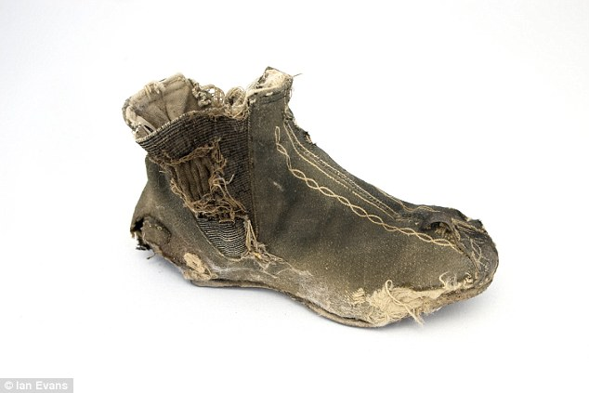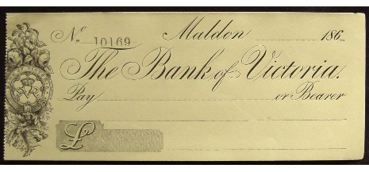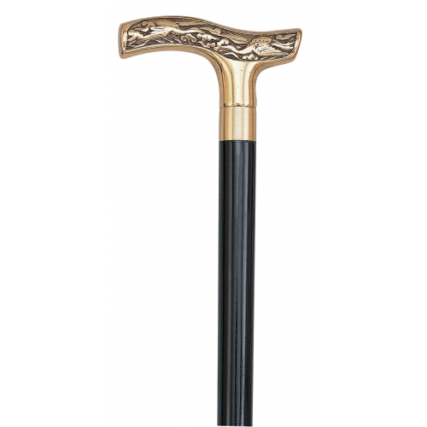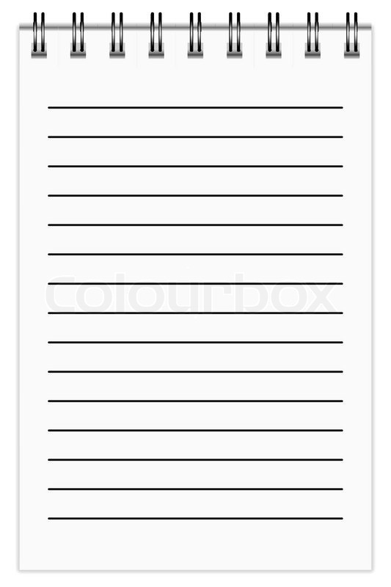

**Time, place etc.**

**Weapon**

**The crime**

**Use the prompts on the sheet to collect everything we know so far about Mr Hyde and his activities.**

**Statement: maidservant**

**“I recognised him straight away...”**

**Statement: Housekeeper**

**“I knew he was a baddun…’**

**Previous Assault: Witness – Enfield**

**Victim**

**Age:**

**Appearance:**

**Address:**

**Actions relating to the crime:**

**Mr Hyde - Profile**