THE EGG HUNTERS
H. C. Barcley describes hunting for the eggs of large birds of prey in the 1860s. He and his companions are hunting in the flood plains of the River Danube. When river water is low, there are islands in the river but, when it floods in the spring, the water comes right up to the level of the trees.
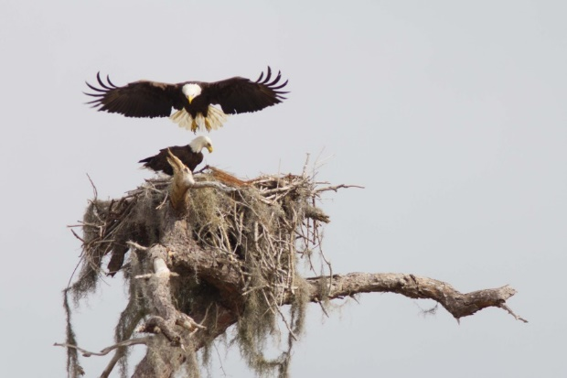
Those egg hunters who are not used to the habits of the vulture and eagle let the spring get too advanced before they go nesting. Then they give themselves the trouble and danger of a climb up a big tree or over the face of the precipitous cliff, only to find the nest filled not with eggs, but with great, downy, young birds with their big beaks and fierce, angry-looking eyes.
Most of the eagles lay their eggs in February and I have taken them when the ground has been inches deep in snow, and when I would have supposed the frost was severe enough to kill the poor mother bird as she sat on her eggs. Much has been written about the danger of being attacked by the eagles whilst taking eggs from their nests. But from my own experience I should say the eagle is the most cowardly bird. No, there is enough danger in the climb without the imaginary one of being pecked at.
These birds are not afraid of the egg hunters and the eagle, falcon and hawk often build on trees a three-year-old could climb. I can remember looking into a splendid sea-eagle’s nest as I sat on my horse under the bough of a low bush. Out on the grassy plains, where there are no trees at all, the eagles actually build their nests on the ground. The most favourable place for nesting, however, is in the big trees on the river islands where it is perfectly quiet and there is a rich feeding ground within easy reach on both sides of the river.
Two of my companions made a most unpleasant discovery whilst eagle-nesting on one of these islands. They had climbed many trees without success but at last they reached the top branches of a tree from where they could see what they thought was a nest at the top. One of them stripped off his coat and climbed further up the tree; but he was astonished on reaching the supposed nest to find it only a bundle of decaying rags, with a shepherd’s crook sticking out of them! Perching himself on a secure bough, he pulled aside the rags and revealed a skeleton of a man, the bleached bones of which went falling to the ground as soon as disturbed, quickly followed by the horrified nester, who never stopped running until the river separated him from his ghastly discovery.
These islands are visited by the shepherds with their flocks and I have no doubt this poor fellow had been surprised by the spring flood and, to escape the water, had been driven up the tree where he had remained a prisoner until he starved to death. His flock would have been drowned and no doubt his friends supposed he had been washed away down the river with them.

THE EGG HUNTERS
H. C. Barcley describes hunting for the eggs of large birds of prey in the 1860s. He and his companions are hunting in the flood plains of the River Danube. When river water is low, there are islands in the river but, when it floods in the spring, the water comes right up to the level of the trees.
Those egg hunters who are not used to the habits of the vulture and eagle let the spring get too advanced before they go nesting. Then they give themselves the trouble and danger of a climb up a big tree or over the face of the precipitous cliff, only to find the nest filled not with eggs, but with great, downy, young birds with their big beaks and fierce, angry-looking eyes.
Most of the eagles lay their eggs in February and I have taken them when the ground has been inches deep in snow, and when I would have supposed the frost was severe enough to kill the poor mother bird as she sat on her eggs. Much has been written about the danger of being attacked by the eagles whilst taking eggs from their nests. But from my own experience I should say the eagle is the most cowardly bird. No, there is enough danger in the climb without the imaginary one of being pecked at.
These birds are not afraid of the egg hunters and the eagle, falcon and hawk often build on trees a three-year-old could climb. I can remember looking into a splendid sea-eagle’s nest as I sat on my horse under the bough of a low bush. Out on the grassy plains, where there are no trees at all, the eagles actually build their nests on the ground. The most favourable place for nesting, however, is in the big trees on the river islands where it is perfectly quiet and there is a rich feeding ground within easy reach on both sides of the river.
Two of my companions made a most unpleasant discovery whilst eagle-nesting on one of these islands. They had climbed many trees without success but at last they reached the top branches of a tree from where they could see what they thought was a nest at the top. One of them stripped off his coat and climbed further up the tree; but he was astonished on reaching the supposed nest to find it only a bundle of decaying rags, with a shepherd’s crook sticking out of them! Perching himself on a secure bough, he pulled aside the rags and revealed a skeleton of a man, the bleached bones of which went falling to the ground as soon as disturbed, quickly followed by the horrified nester, who never stopped running until the river separated him from his ghastly discovery.
These islands are visited by the shepherds with their flocks and I have no doubt this poor fellow had been surprised by the spring flood and, to escape the water, had been driven up the tree where he had remained a prisoner until he starved to death. His flock would have been drowned and no doubt his friends supposed he had been washed away down the river with them.

