An Inspector Calls by J B Priestley
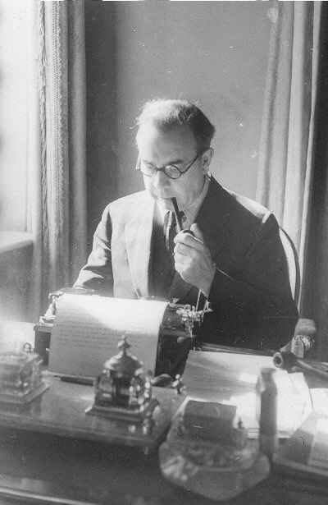

The Author’s Ideas and Perspectives (AO3ii)

Read the notes you have been given and then answer these questions.

The Author
- When and where was Priestley born?
- For whom did Priestley first work and how may this have influenced his beliefs about workers?
- What is socialism (a brief definition!)?
- What was Priestley particularly disappointed about as a socialist?
- What could this play be seen as?
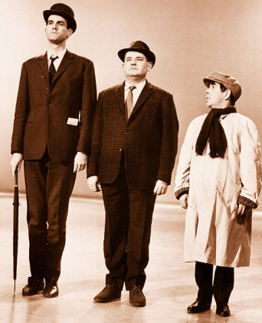
Social Position
- How had many men made their fortunes?
- What did this enable them to do?
- Why do you think older families might have disapproved of these ‘newly rich’ people? Think about the strength of the class system and how it divided society.
- How does Mr Birling fit into these ideas and how is he expecting to be raised further up the social ladder?
- As a result, how does he (and Mrs Birling) treat the Inspector?

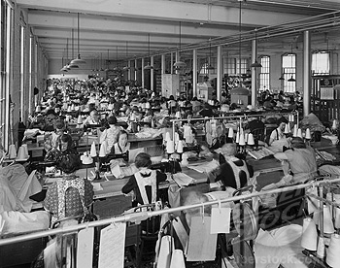
Workers and Bosses
- As a worker, what sort of conditions could you expect?
- If you were sacked from your job, what were the consequences?
- What is different about society now?
- Explain whether you think Eva Smith was right to protest about working conditions and whether she was right to be one of the leaders of the strike.
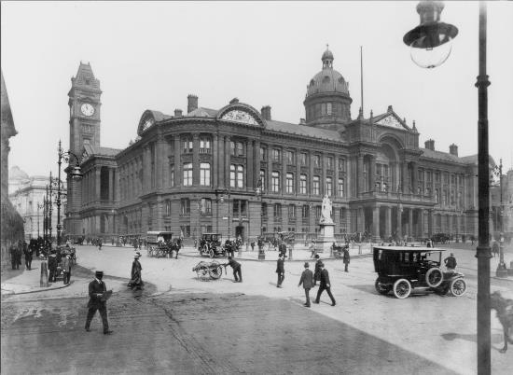
- What happens to Eva after she is sacked from Milwards?

Setting and Place
- In which fictional town is ‘An Inspector Calls’ set and what can we deduce about it?
- Why might a fictional town be used rather than the name of a real town?
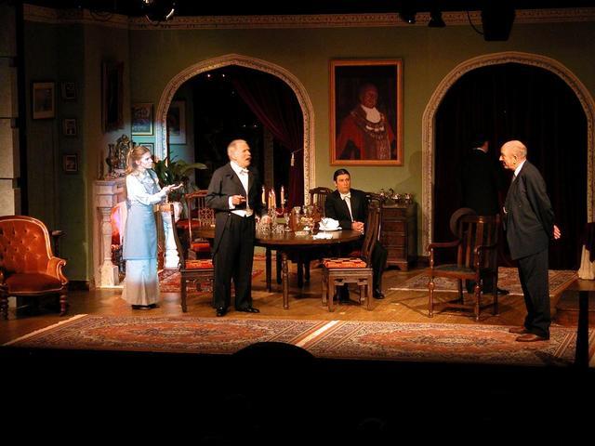
- Where does the action of the play take place and how is it described in the stage directions?
- What does this setting symbolise – think about the specific example you have and the wider connotations too.
- Why does Priestley want to create a normal setting?

