Macbeth: The Simplified Story
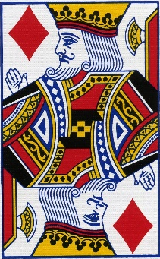
The play begins with the brief appearance of a trio of witches and then moves to a military camp, where the Scottish King Duncan hears the news that his generals, Macbeth and Banquo, have defeated two separate invading armies—one from Ireland and one from Norway.
Following their battle with these enemy forces, Macbeth and Banquo encounter the witches as they cross a moor. The witches prophesy that Macbeth will be made thane (a rank of Scottish nobility) of Cawdor and eventually King of Scotland. They also predict that Macbeth’s companion, Banquo, will start a line of Scottish kings, although Banquo will never be king himself.
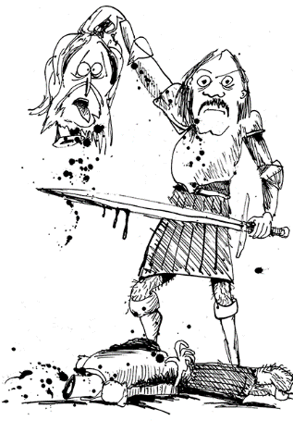
The witches vanish, and Macbeth and Banquo treat their prophecies sceptically until some of King Duncan’s men come to thank the two generals for their victories in battle and to tell Macbeth that he has indeed been named thane of Cawdor. The previous thane betrayed Scotland by fighting for the Norwegians and Duncan has condemned him to death. Macbeth is intrigued by the possibility that the remainder of the witches’ prophecy—that he will be crowned king—might be true, but he is uncertain what to expect. He visits King Duncan, and they plan to dine together at Inverness, Macbeth’s castle, that night. Macbeth writes ahead to his wife, Lady Macbeth, telling her all that has happened.
Lady Macbeth suffers none of her husband’s uncertainty. She desires the kingship for him and wants him to murder Duncan in order to obtain it. When Macbeth arrives at Inverness, she overrides all of her husband’s objections and persuades him to kill the king that very night.
He and Lady Macbeth plan to get Duncan’s two chamberlains drunk so they will black out; the next morning they will blame the murder on the chamberlains, who will be defenceless, as they will remember nothing.
While Duncan is asleep, Macbeth stabs him, despite his doubts and a number of supernatural portents, including a vision of a bloody dagger. When Duncan’s death is discovered the next morning, Macbeth kills the chamberlains—pretending to be outraged at their crime—and soon becomes king. Duncan’s sons Malcolm and Donalbain flee to England and Ireland, respectively, fearing that whoever killed Duncan desires their deaths as well.
Fearful of the witches’ prophecy that Banquo’s heirs will seize the throne, Macbeth hires a group of murderers to kill Banquo and his son Fleance. They ambush Banquo on his way to a royal feast, but they fail to kill Fleance, who escapes into the night. Macbeth becomes furious: as long as Fleance is alive, he fears that his power remains insecure.
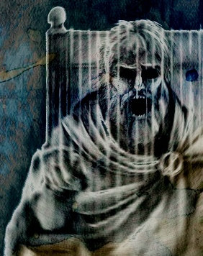
At the feast that night, Banquo’s ghost visits Macbeth. When he sees the ghost, Macbeth raves fearfully, startling his guests, who include most of the great Scottish nobility. Lady Macbeth tries to neutralize the damage, but Macbeth’s kingship now falls under suspicion from his nobles and subjects.
Frightened, Macbeth goes to visit the witches in their cavern. There, they show him a sequence of demons and spirits who present him with further prophecies: he must beware of Macduff, a Scottish nobleman who opposed Macbeth’s accession to the throne; he is incapable of being harmed by any man born of woman; and he will be safe until Birnam Wood comes to Dunsinane Castle. Macbeth is relieved and feels secure, because he knows that all men are born of women and that forests cannot move. When he learns that Macduff has fled to England to join Malcolm, Macbeth orders that Macduff’s castle be seized and, most cruelly, that Lady Macduff and her children be murdered. When news of his family’s execution reaches Macduff in England, he is stricken with grief and vows revenge.
Prince Malcolm, Duncan’s son, has succeeded in raising an army in England, and Macduff joins him as he rides to Scotland to challenge Macbeth’s forces. The invasion has the support of the Scottish nobles, who are appalled and frightened by Macbeth’s tyrannical and murderous behaviour.
Lady Macbeth, meanwhile, becomes plagued with fits of sleepwalking in which she bemoans what she believes to be bloodstains on her hands. Before Macbeth’s opponents arrive, Macbeth receives news that she has killed herself, causing him to sink into a deep and pessimistic despair.
Nevertheless, he awaits the English and fortifies Dunsinane, to which he seems to have withdrawn in order to defend himself, certain that the witches’ prophecies guarantee his invincibility. He is struck numb with fear, however, when he learns that the English army is advancing on Dunsinane shielded with boughs cut from Birnam Wood. Birnam Wood is indeed coming to Dunsinane, fulfilling half of the witches’ prophecy.
In the battle, Macbeth fights violently, but the English forces gradually overwhelm his army and castle. On the battlefield, Macbeth encounters the vengeful Macduff, who declares that he was not “of woman born” but was instead “untimely ripped” from his mother’s womb (what we now call birth by caesarean section). Though he realizes that he is doomed, Macbeth continues to fight until Macduff kills and beheads him. Malcolm, now the King of Scotland, declares his benevolent intentions for the country and invites all to see him crowned at Scone.
‘Macbeth’: The Plot
Answer these questions in full sentences to support your understanding of the play and future revision.
- Which characters open the play?
- King Duncan hears news that which armies have been defeated by Macbeth and Banquo?
- What do the witches tell Macbeth and Banquo when they meet them on the moor? List the prophecies.
- What happens to Macbeth to prove the first prophecy to be true?
- How does Macbeth inform Lady Macbeth about what has happened?
- What does Lady Macbeth want her husband to do to ensure that the prophecies come true?
- What plan do the Macbeths hatch to carry out the deed?
- What does Macbeth think that he sees as he prepared to kill King Duncan?
- How does Macbeth cover his tracks before becoming king?
- What do King Duncan’s sons do? Why?
- Who does Macbeth have killed next? Why?
- Who escapes and why is this important?
- What unexpected guest attends Macbeth’s feast?
- How does Macbeth react to this visitor and what effect does it have on his guests?
- Who does Macbeth go to visit in a cavern?
- What three new prophecies do the witches share with Macbeth?
- Whose family does Macbeth murder to punish him for joining King Duncan’s son, Malcolm, in England?
- What has Prince Malcolm done in England and what does he plan to do in Scotland?
- What happens to Lady Macbeth?
- Why has Macbeth fortified Dunsinane Castle?
- How does the witches’ prophecy start to come true, terrifying Macbeth?
- Why is Macduff a real threat to Macbeth?
- How does the battle end?
- Who becomes the rightful king of Scotland?

