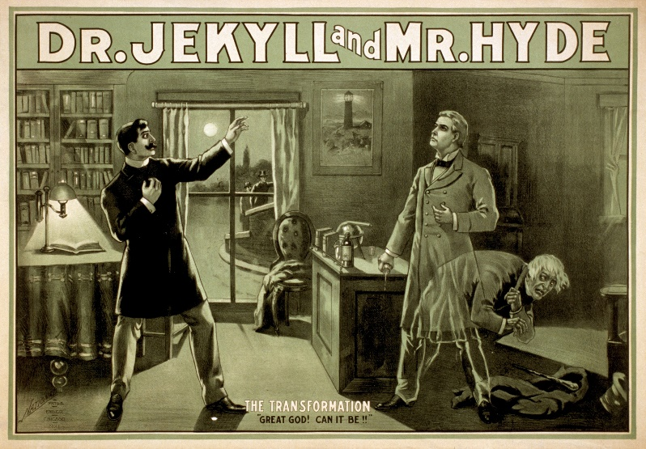

Working Class London

**Victorian Britain**

Changes and Inventions

Gentlemen and Reputation

(Public and Private or ‘The Victorian Compromise’)

Religion and Science (Darwin, Freud)

Robert Louis Stevenson

Real Crime

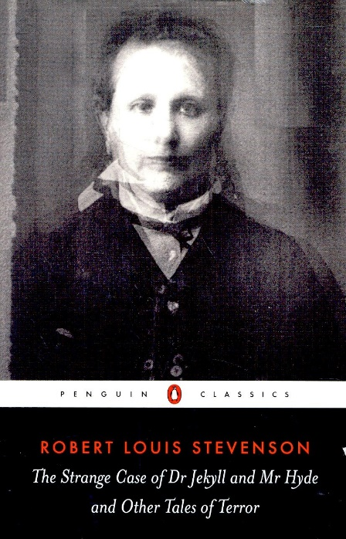

Horror fiction and ‘the Gothic’

Romanticism